4. Project scenarios: hands-on Windows 11 troubleshooting

Scenario 1 – Sign-in, password and PIN issues
IT Help Desk Incident – Forgotten Password
Incident: INC-001
Category: Windows 11 – User Account / Sign-in
Priority: Low – Training Lab
Reported issue:
The user reported that they could not sign in to their Windows 11 computer because they had forgotten their local account password.

Initial investigation:
- Confirmed the affected username.

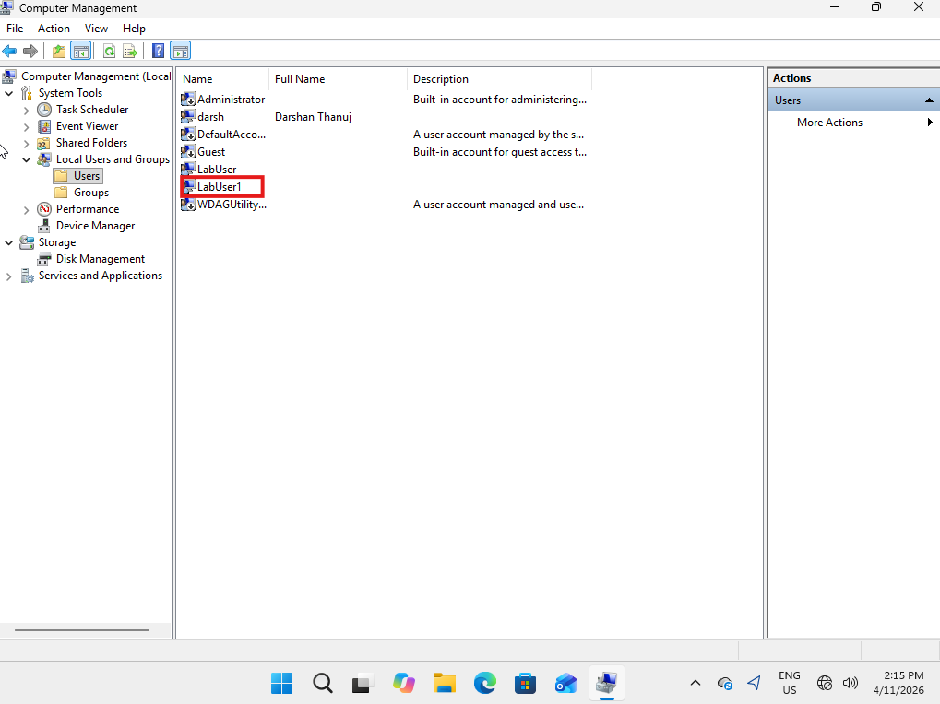

Purpose:
To verify that the username reported by the user exists on the affected Windows computer before proceeding with further sign-in troubleshooting.

Investigation performed:
- Opened Computer Management
- Navigated to System Tools → Local Users and Groups → Users.
- Reviewed the list of local user accounts.
- Located and confirmed the affected username (LabUser1).
- Checked that the account was present in the local user account list.
Result:
The affected username was successfully located in the local user account list. This confirmed that the account exists on the Windows computer.

Note: Confirming that an account exists does not automatically prove that it is enabled, unlocked or has the correct password. These items require separate checks.

- Checked keyboard layout and Caps Lock.
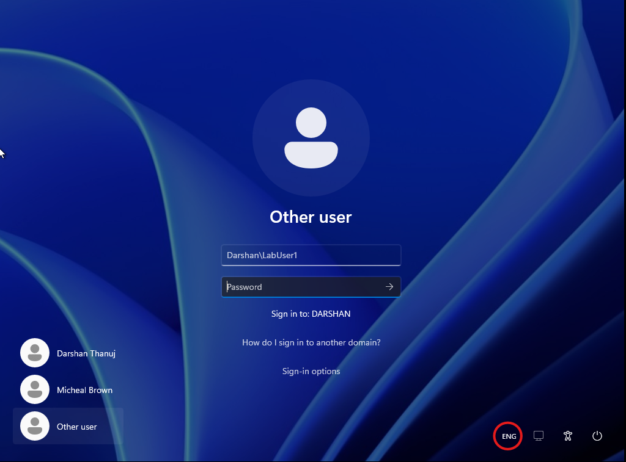

Purpose:
To rule out incorrect keyboard input settings as a possible cause of the user's sign-in problem.
Investigation performed:
- Checked the keyboard language indicator on the Windows sign-in screen.
- Confirmed that the selected keyboard input language was English (ENG).
- Checked the physical keyboard to ensure Caps Lock was disabled.
- Considered whether an incorrect keyboard layout could cause special characters or passwords to be entered incorrectly.
Result:
The keyboard input language was confirmed as English (ENG), and Caps Lock was checked. No keyboard-related issue was identified during the investigation.

- Confirmed the computer was displaying the Windows sign-in screen.

- Identified the account as a local Windows account.
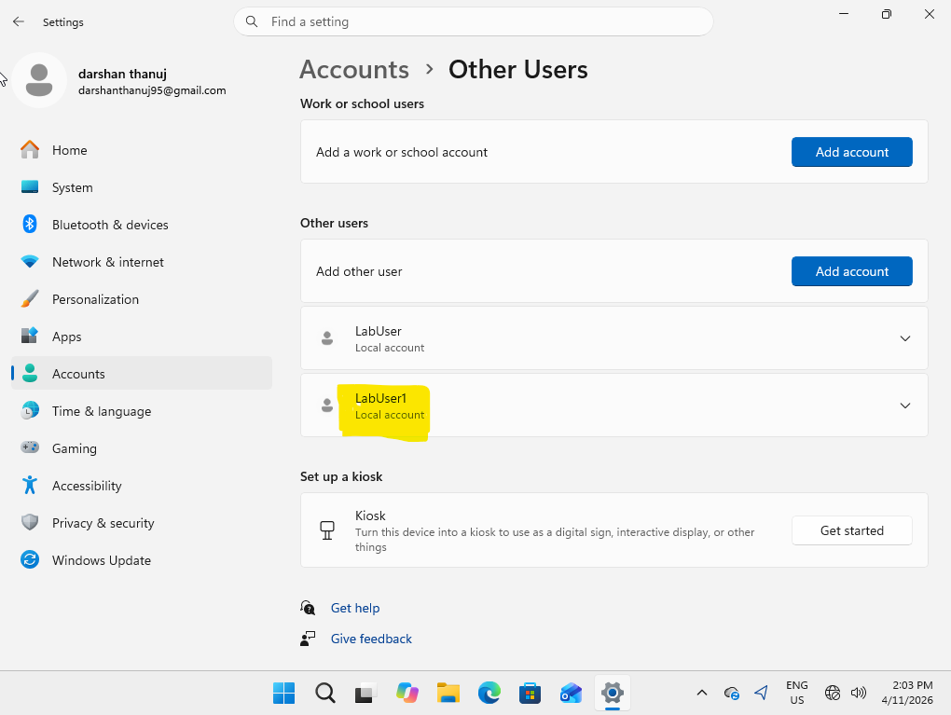

Purpose:
To identify whether the affected user account is a local Windows account or an account managed through an organisation's domain or cloud identity service.
Investigation performed:
- Opened Windows Settings.
- Navigated to Accounts → Other users.
- Located the affected account (LabUser1).
- Reviewed the account information displayed in Windows Settings.
- Confirmed that the account was configured as a local Windows account.
Result:
Identified the affected account as a local Windows account. This means the account is managed directly on the local computer rather than through Active Directory or Microsoft Entra ID.
Troubleshooting consideration:
Local account password issues can be investigated using Windows local account management tools, such as Computer Management or the appropriate Windows account settings.

Troubleshooting performed:
- Signed in using an authorised administrator account.
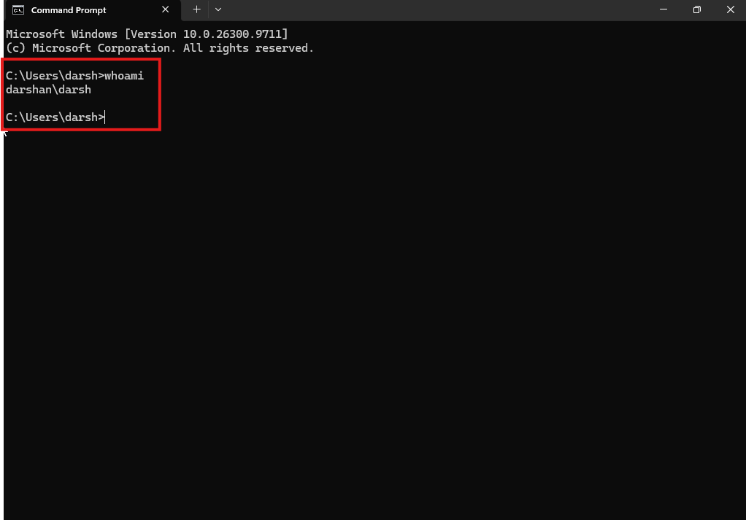
Purpose:
To verify that the troubleshooting session was performed using an authorised administrator account.
Investigation performed:
- Signed in to the Windows 11 computer using the administrator account.
- Opened Command Prompt.
- Executed the following command:
whoami
- Reviewed the output to identify the currently signed-in account.
- Confirmed that the displayed username belonged to the administrator account used for the lab exercise.
Result:
Successfully verified the currently signed-in administrator account using the whoami command.
Troubleshooting consideration:
Administrator access is required for certain troubleshooting activities, including managing local user accounts and changing account settings. Access should only be used when authorised.

- Navigated to Local Users and Groups.

Purpose:
To access Windows local account management tools and locate the affected user account for further investigation.
Investigation performed:
- Opened the Run dialog using Windows + R.
- Entered compmgmt.msc and pressed Enter.
- Expanded System Tools → Local Users and Groups → Users.
- Located and highlighted the affected account (LabUser).
- Prepared to inspect the account properties and status.
Result:
Successfully accessed Computer Management and located the affected local Windows account (LabUser).
Troubleshooting consideration:
Computer Management allows authorised administrators to manage local user accounts, check account properties, and perform certain account-management tasks.

- Reset the test account password.

Screenshot 1: Right-clicked LabUser1 and selected Set Password.

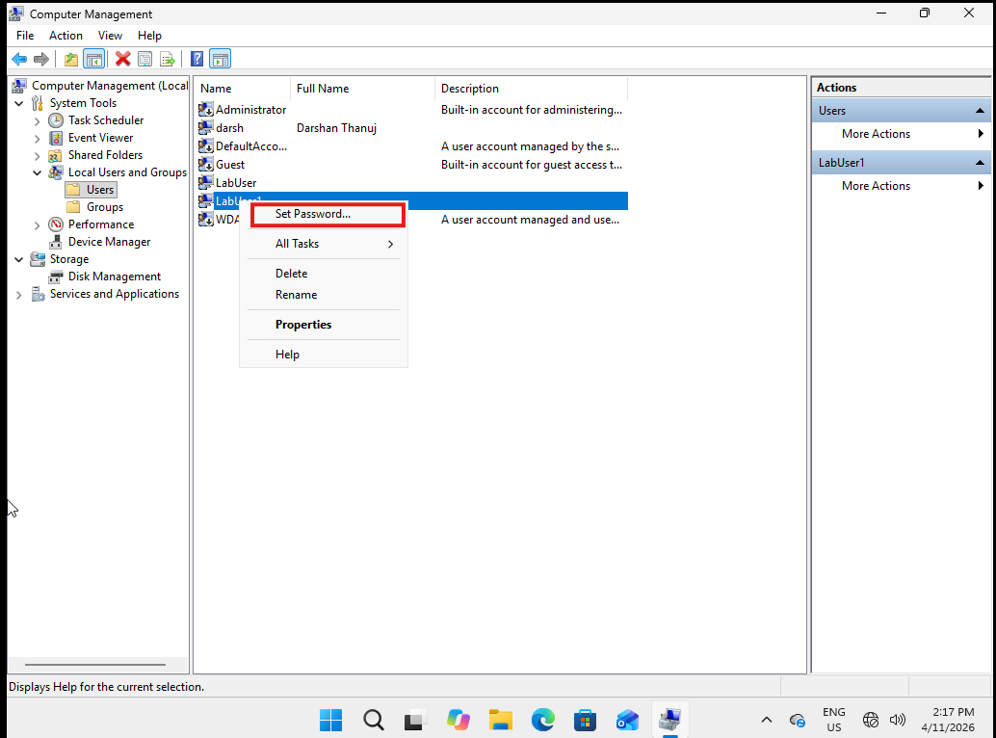

Screenshot 2: Windows displayed the password-reset warning message

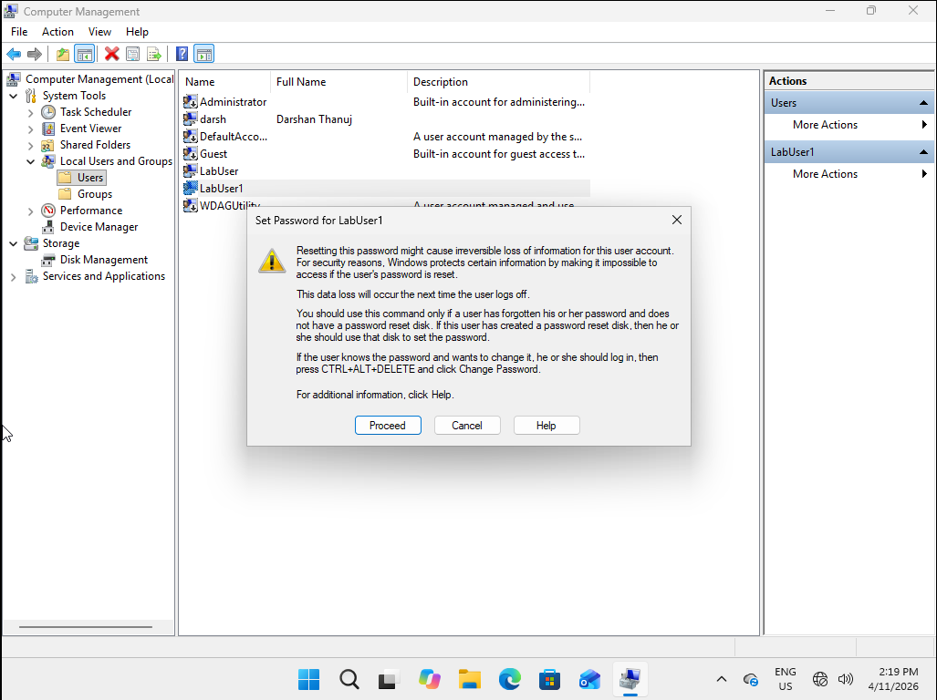

Screenshot 3: Entered and confirmed the new test password.

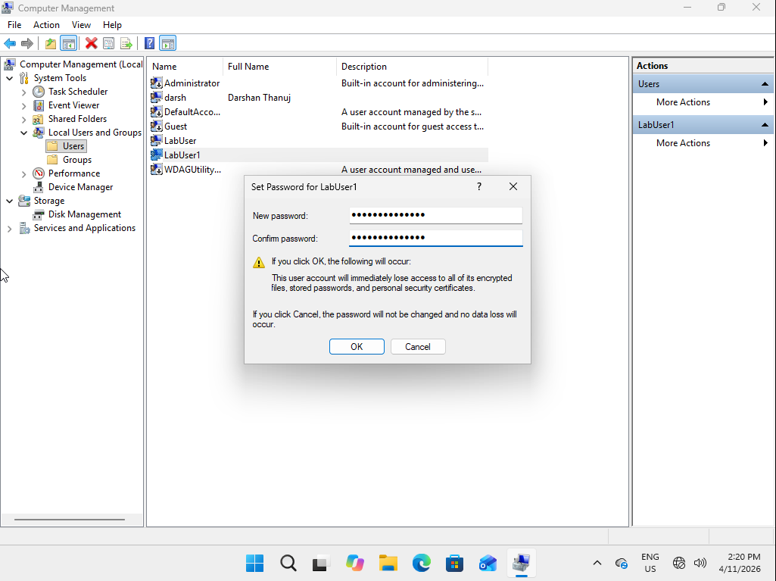

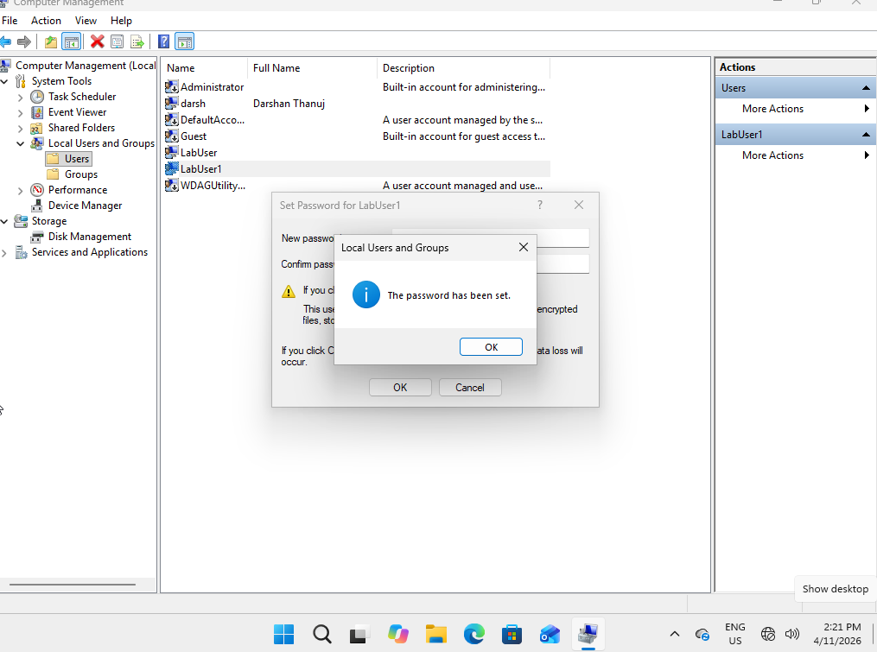
Resolution:
Reset the password for the test local account.
Verification:
Signed out of the administrator account and successfully signed in using the new test password.

Screenshot 1: Successfully signed in to Windows using the LabUser1 username and newly reset test password

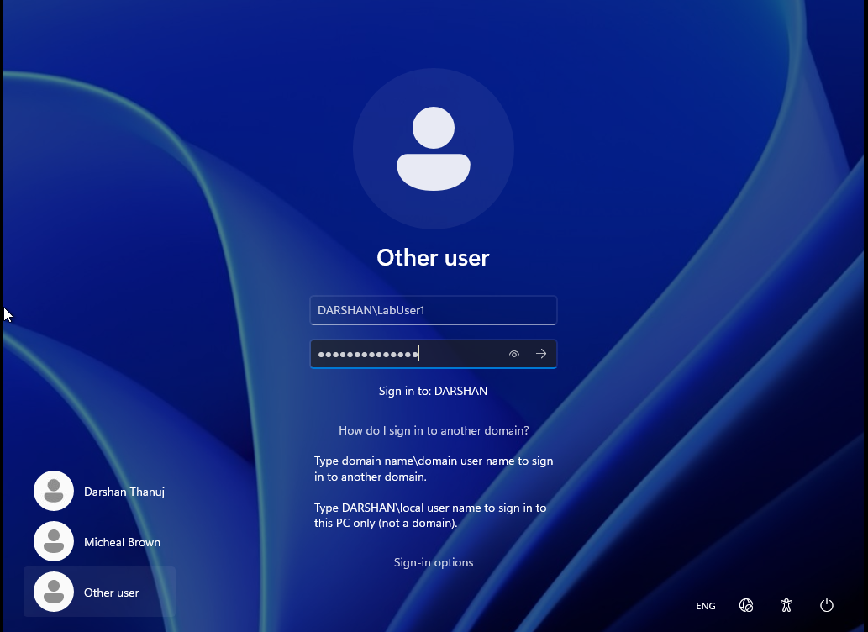

Screenshot 2: Opened Command Prompt and executed whoami to verify the currently signed-in account

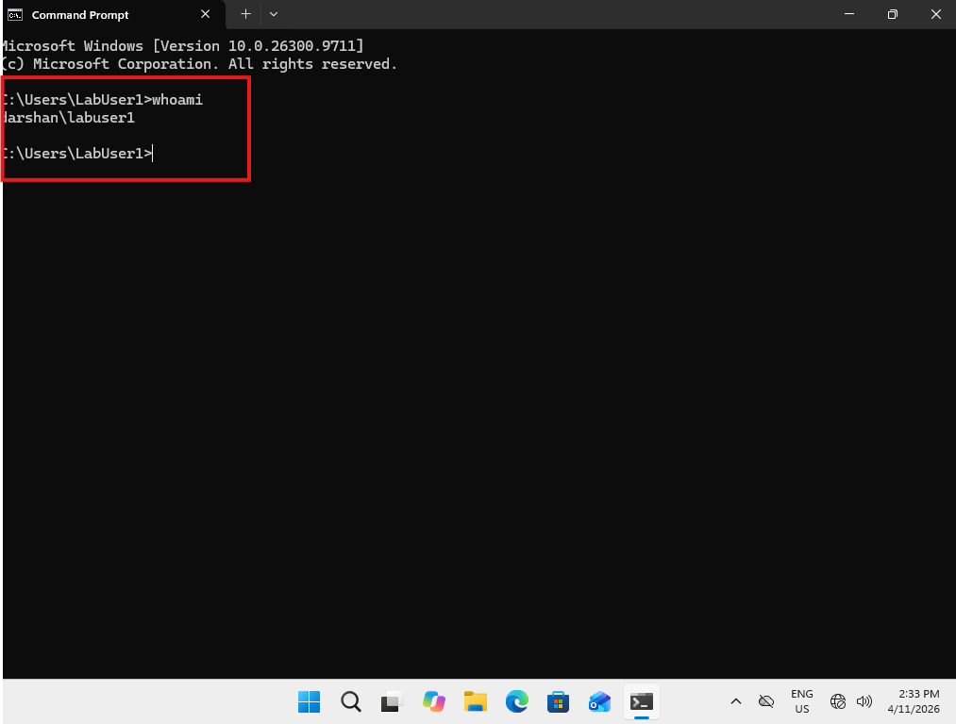
Purpose:

To verify that the password reset was successful and that the affected local user account can authenticate and access the Windows desktop.
Investigation and actions performed:
- Signed out of the administrator account.
- Returned to the Windows sign-in screen.
- Selected the LabUser1 account.
- Entered the newly configured test password.
- Successfully signed in and accessed the Windows desktop.
- Opened Command Prompt.
- Executed the following command:
whoami
- Reviewed the command output to confirm that the currently signed-in account was LabUser1.

Result:
Successfully authenticated using the new test password and accessed the Windows desktop. The whoami command confirmed that the active user session belonged to the intended local test account.

Resolution:
The simulated forgotten local password issue was successfully resolved and verified in the Windows 11 lab environment.

Final status: Resolved – Training Lab
Important: This incident was simulated in a personal Windows 11 virtual machine.

Scenario 2 – Network and internet connectivity
Incident INC-002 – Network Connectivity Troubleshooting
User: Sarah Jones
Device: Windows 11 Pro VM
Category: Network Connectivity
Priority: P3 – Medium
1. User-reported issue
User reported being unable to access external websites and experiencing Microsoft Outlook synchronisation issues.
2. Investigation performed
- Verified the affected user and computer details.
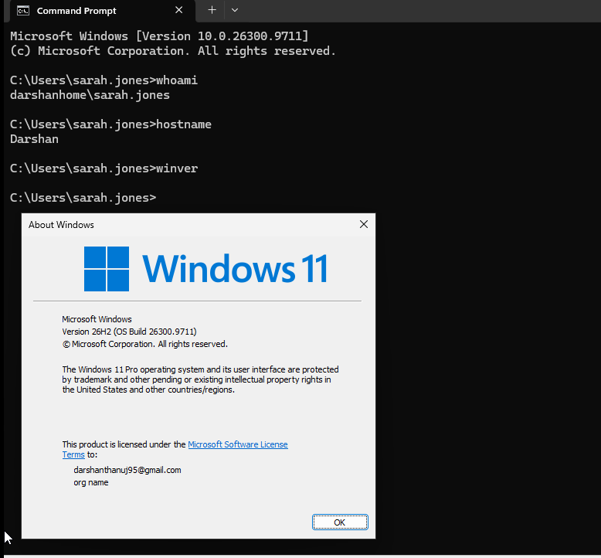
Purpose:
To identify the affected user, workstation and operating system before starting network connectivity troubleshooting.
Investigation performed:
- Opened Command Prompt on the Windows 11 workstation.
- Executed whoami to identify the currently signed-in user.
- Executed hostname to identify the computer name.
- Executed winver to verify the Windows operating system version and build.
Result:
Successfully verified the currently signed-in user, computer hostname and Windows operating system information.
Evidence collected:
A screenshot showing the command outputs and Windows version information was captured and saved as part of the troubleshooting documentation.
Troubleshooting consideration:
Verifying the affected user and workstation ensures that the investigation is performed on the correct device and that the incident is accurately documented.

- Checked Ethernet connection status.
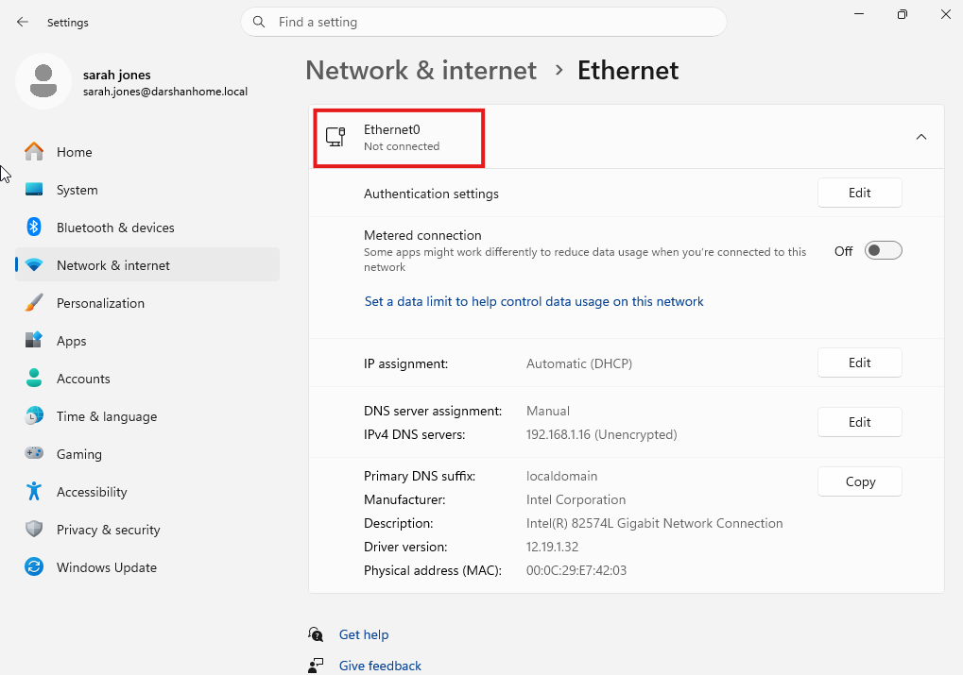

Ethernet Connection Status: Not Connected.

Purpose:
To determine whether the Windows workstation recognises an active Ethernet network connection.
Investigation performed:
Signed in using Sarah Williams' test account and opened Settings → Network & internet. Checked the Ethernet connection status and reviewed the network information displayed by Windows.
Result:
Recorded the Ethernet connection status displayed in Windows Settings. This helped establish whether the workstation recognised a network connection before performing further connectivity tests.
Evidence:
Screenshot captured from Windows Settings → Network & internet while signed in as Sarah Williams.

- Verified VMware virtual network adapter configuration.

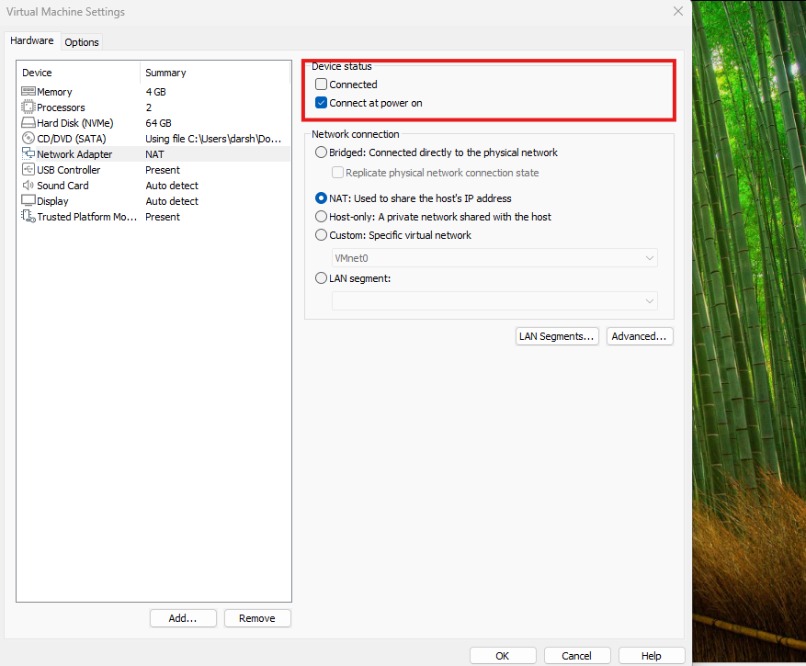

Step 3 – Verified VMware Virtual Network Adapter Configuration
Purpose:
To check whether the virtual machine's network adapter was connected and configured correctly in VMware.
Investigation performed:
Opened the VMware virtual machine settings and inspected the Network Adapter configuration. Checked the network connection options, including the Connected and Connect at power on settings.
Result:
The Connected option was unticked, indicating that the virtual network adapter was disconnected from the virtual machine.
Evidence:
Screenshot captured from VMware Network Adapter settings showing the Connected option unticked.
Troubleshooting consideration:
A disconnected VMware network adapter prevents the virtual machine from communicating through that virtual network connection. This was a potential cause of Sarah Jones' reported network connectivity issue. Further testing and reconnection were required to confirm the resolution.

- Checked Windows network adapter status.

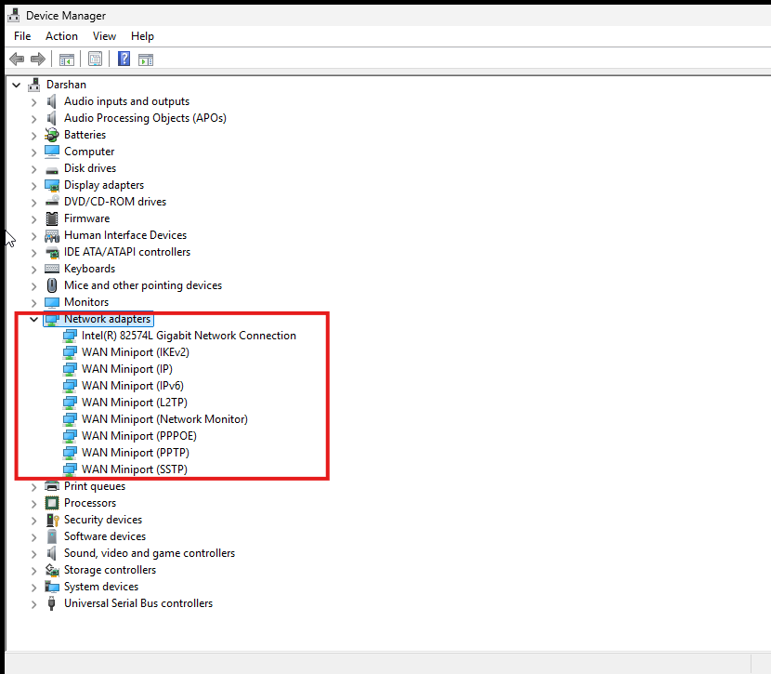

Step 4 – Checked Network Adapter Status in Device Manager
Purpose:
To verify whether Windows recognises the network adapter and identify any visible driver or device-related issues.
Investigation performed:
Opened Device Manager and expanded the Network adapters section. Inspected the listed network adapters for warning symbols, disabled devices or other visible errors.
Result:
Windows successfully displayed the installed network adapters. No yellow warning indicators, disabled-device symbols or other visible errors were identified.
Evidence:
Screenshot captured showing the expanded Network adapters section in Device Manager.
Troubleshooting consideration:
The absence of visible warning indicators suggests there are no obvious device or driver errors reported by Device Manager. However, this does not confirm that the network adapter is connected or that internet connectivity is working. Further network configuration and connectivity tests are required.

- Inspected IP configuration using ipconfig /all.
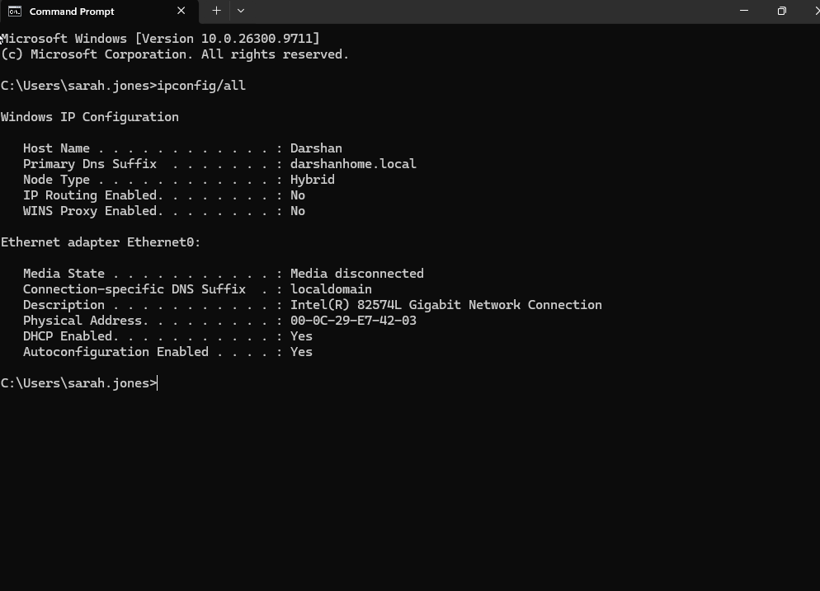
Step 5 – Inspected IP Configuration Using ipconfig /all
Purpose:
To examine the workstation's network configuration and determine whether it has received valid network settings.
Investigation performed:
Opened Command Prompt and executed ipconfig /all to inspect the network adapter configuration, including IPv4 address, subnet mask, default gateway, DHCP status and DNS server information.
Result:
The output showed that the workstation did not have a valid IPv4 network configuration or an assigned default gateway. This indicated that the virtual machine was not receiving normal network connectivity.
Evidence:
Screenshot captured showing the ipconfig /all command output and network adapter configuration.
Troubleshooting consideration:
The absence of a valid IP address and default gateway suggested that the workstation was unable to establish network communication. The VMware virtual network adapter configuration was identified as an area requiring further investigation.

- Tested local network connectivity using ping.
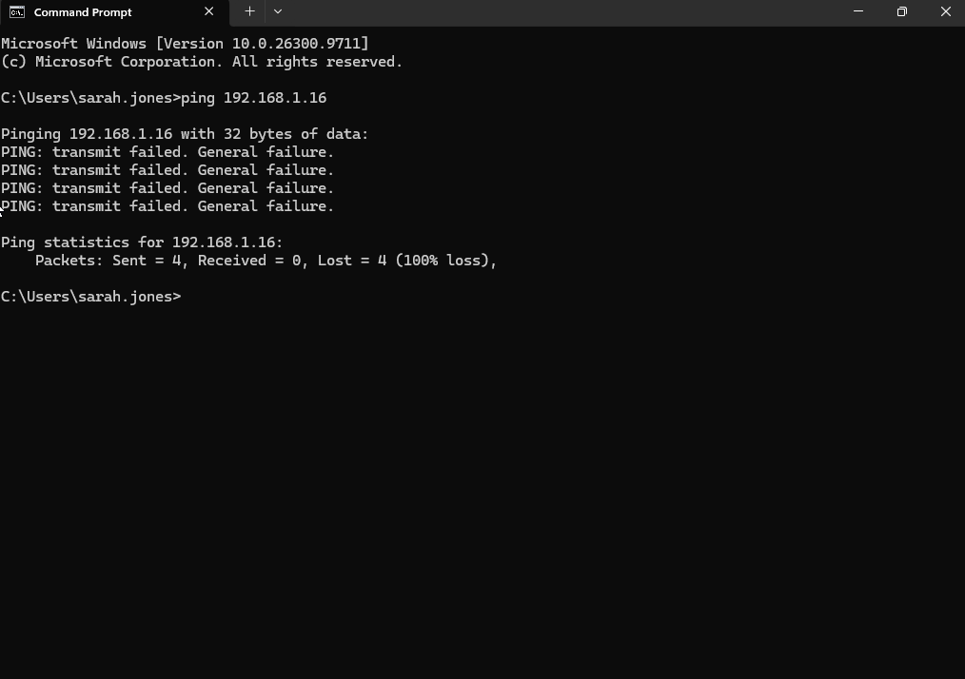
Purpose:
To determine whether the Windows workstation could communicate with the Domain Controller over the network.
Investigation performed:
Opened Command Prompt and executed the following command:
ping 192.168.1.16
Observed the responses to determine whether the workstation could successfully reach the Domain Controller.
Result:
The ping test returned 100% packet loss, with no successful replies received from the Domain Controller.
Evidence:
Screenshot captured showing the failed ping test and 100% packet loss.
Troubleshooting consideration:
The failed test indicated that the workstation could not establish successful ICMP communication with the Domain Controller at the time of testing. Possible causes include network adapter disconnection, incorrect network configuration, routing issues or ICMP traffic being blocked by a firewall.

- Tested external IP connectivity.
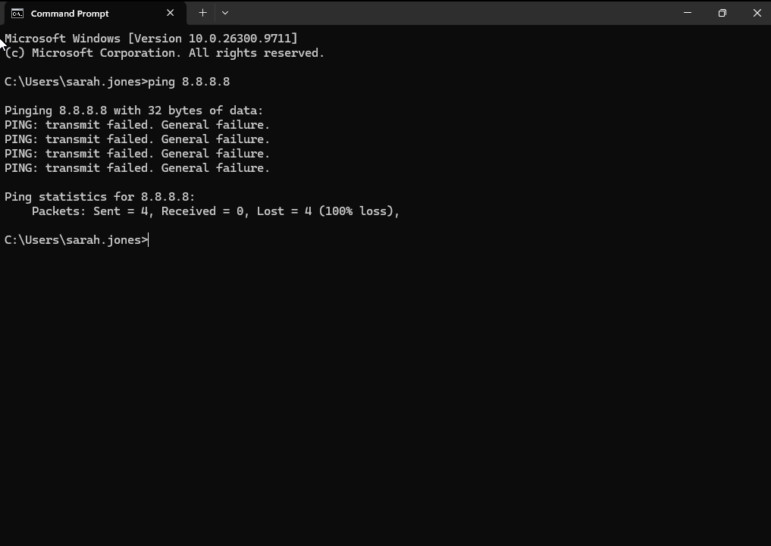

Purpose:
To determine whether the workstation could communicate with an external IP address without relying on DNS name resolution.
Investigation performed:
Opened Command Prompt and executed:
ping 8.8.8.8
This test was performed to check whether the workstation could reach Google's public DNS server using ICMP.
Result:
The ping test failed, returning 100% packet loss with no successful replies received.
Evidence:
Screenshot captured showing the failed ping test to 8.8.8.8.
Troubleshooting consideration:
The failed test indicated that external IP connectivity could not be confirmed. Since the test used an IP address directly, DNS name resolution was not required. Further investigation was needed to identify the underlying network connectivity issue.

- Tested DNS resolution using nslookup.
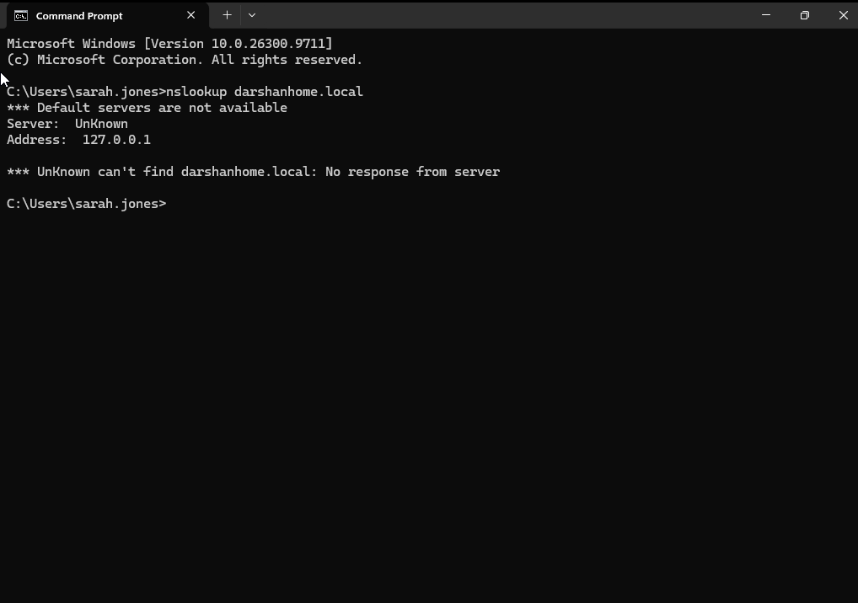

Purpose:
To determine whether the workstation could resolve domain names into IP addresses using DNS.
Investigation performed:
Opened Command Prompt and executed the following command:
nslookup google.com
Reviewed the command output to determine whether the configured DNS server could successfully resolve the hostname.
Result:
The DNS lookup failed. The workstation was unable to successfully resolve google.com at the time of testing.
Evidence:
Screenshot captured showing the failed nslookup google.com command output.
Troubleshooting consideration:
The failed DNS lookup indicated that name resolution was unsuccessful. Possible causes included an unavailable DNS server, incorrect DNS configuration or the disconnected VMware network adapter. Further investigation was required to confirm the underlying cause.

- Compared connectivity with other devices to determine the scope of the issue.

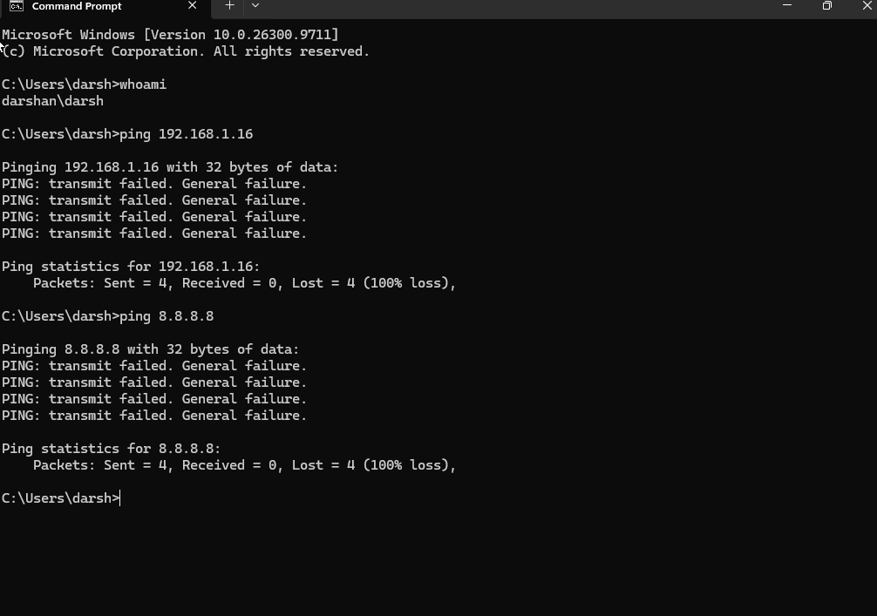
Purpose:
To determine whether the network connectivity issue was isolated to Sarah's virtual machine or potentially affected the physical host computer as well.
Investigation performed:
Performed connectivity tests on the physical host computer running VMware. Executed the following commands in Command Prompt:
- ping 8.8.8.8
- ping 192.168.1.16
Compared the results with the connectivity tests previously performed on Sarah's Windows 11 virtual machine.
Result:
The physical host computer also returned 100% packet loss when pinging both the external IP address (8.8.8.8) and the Domain Controller (192.168.1.16).
Evidence:
Screenshots captured showing the failed ping tests performed on the physical host computer.
Troubleshooting consideration:
The failed ping tests on both the virtual machine and physical host suggested that the issue might not be isolated to the virtual machine. However, ICMP traffic could be blocked, so additional testing was required to determine whether the physical host had working internet access.

3. Findings
Confirmed root cause:
The VMware virtual network adapter assigned to Sarah's Windows 11 virtual machine was disconnected. The Connected option was unticked in VMware Network Adapter settings.

Impact:
The virtual machine could not communicate through its virtual network adapter, resulting in failed connectivity tests.
Supporting evidence:
- VMware Network Adapter screenshot showing Connected unticked.
- No valid network configuration shown in ipconfig /all.
- Failed ping to the Domain Controller.
- Failed ping to external IP address 8.8.8.8.
- Failed DNS resolution using nslookup google.com.

4. Resolution required:
Reconnect the VMware virtual network adapter and perform further connectivity tests to verify successful network communication.

5.Verification and Resolution
Purpose:
To confirm that reconnecting the VMware virtual network adapter restored network connectivity and resolved Sarah Williams' reported issue.
Investigation performed:
After reconnecting the VMware virtual network adapter, performed the following verification checks:
- Ethernet Connection Status: Checked Windows Settings → Network & internet and confirmed that Ethernet showed as connected.
- IP Connectivity – Domain Controller: Successfully pinged the Domain Controller using ping 192.168.1.16.
- External IP Connectivity: Successfully pinged Google's public DNS server using ping 8.8.8.8.
- DNS Resolution: Executed nslookup google.com and confirmed successful hostname resolution.
- Internet Access: Opened Google in the web browser and confirmed that the website loaded successfully.
Result:
All verification tests were successful. The workstation successfully communicated with the Domain Controller, reached an external IP address, resolved internet domain names and accessed Google through the web browser.
Evidence:
Screenshots captured showing:
- Windows Ethernet connection status.
- Successful ping to the Domain Controller.
- Successful ping to 8.8.8.8.
- Successful DNS lookup using nslookup.
- Successful access to Google through the web browser.
Resolution:
Reconnected the VMware virtual network adapter by enabling the Connected option in VMware settings. This restored network connectivity to Sarah's Windows 11 virtual machine.

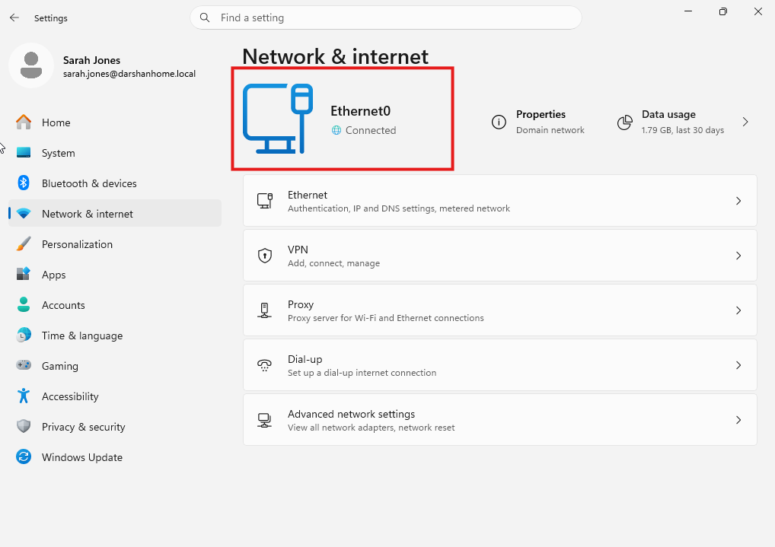
Windows Ethernet connection status- Connected.

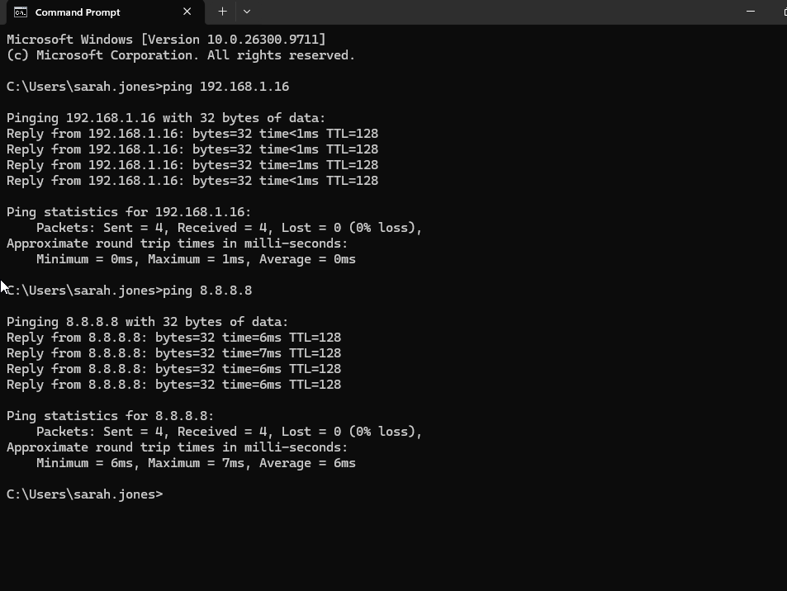

Successful ping to the Domain Controller and 8.8.8.8.

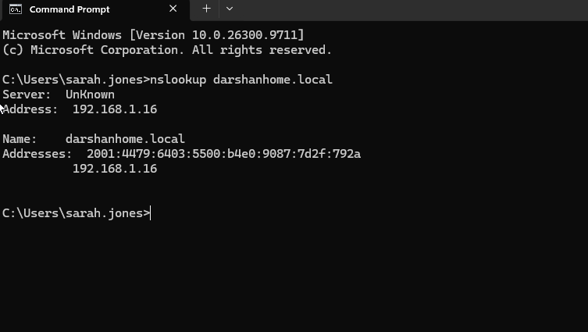

Successful DNS lookup using nslookup.

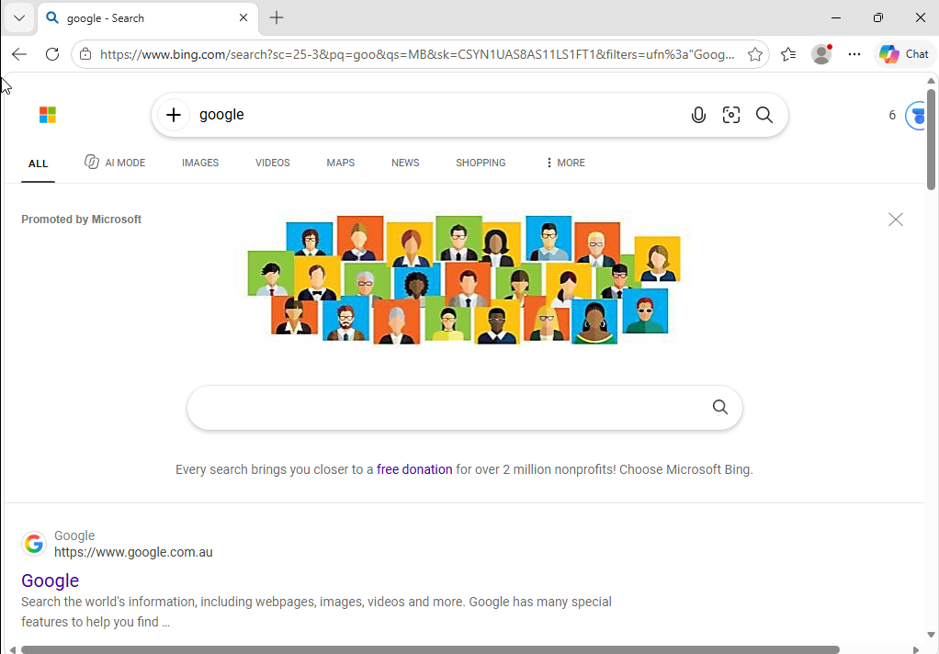

Successful access to Google through the web browser.

Final Status:
Resolved – Network connectivity successfully restored and verified

Scenario 3 – Slow Windows 11 computer
Scenario 3 – Slow Windows 11 Computer
IT Help Desk Incident Ticket
Ticket ID: INC-003
Reported By: Emma Brown
Department: Finance
Affected Device: Windows 11 Workstation
Operating System: Windows 11 Pro
Priority: P3 – Medium
Category: Hardware / Operating System Performance
Status: Open
Assigned To: Level 1 IT Support
Reported Via: Email
1. User-Reported Issue
Subject: Computer running very slowly
Hi IT Support,
My computer has been running very slowly since this morning. It takes a long time to start up and sign in. Applications such as Microsoft Outlook and Excel are taking longer than usual to open.
The computer sometimes freezes for a few seconds when I switch between applications. I have tried restarting it, but the problem is still happening.
Could someone please investigate?
Thanks,
James Anderson
Finance Department

2. Initial Incident Assessment
Reported symptoms:
- Slow Windows startup.
- Delayed sign-in.
- Applications taking longer than usual to launch.
- Temporary freezing when switching between applications.
- Restarting the computer has not resolved the issue.
Business impact:
The user is experiencing delays when accessing applications and completing daily Finance tasks.
Initial priority:
P3 – Medium, subject to business impact and service desk prioritisation.
3. Initial Troubleshooting Objectives
- Identify the affected user and workstation.
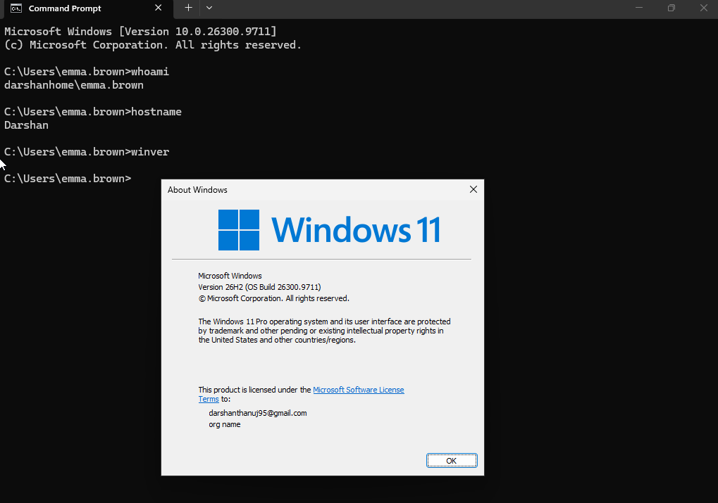
Purpose:
To identify the affected user account, workstation name and Windows operating system before beginning troubleshooting.
Investigation performed:
Opened Command Prompt and executed the following commands:
- whoami – identified the currently signed-in user.
- hostname – identified the workstation's computer name.
- winver – checked the Windows version and operating system build.
Result:
Successfully identified the signed-in user, workstation name and Windows 11 operating system details.
Evidence:
Screenshot captured showing the command outputs for whoami, hostname and winver.
Troubleshooting consideration:
Verifying the affected user and workstation ensures that troubleshooting is performed on the correct device and that incident documentation contains accurate system information.

- Check CPU, memory and disk utilisation using Task Manager.
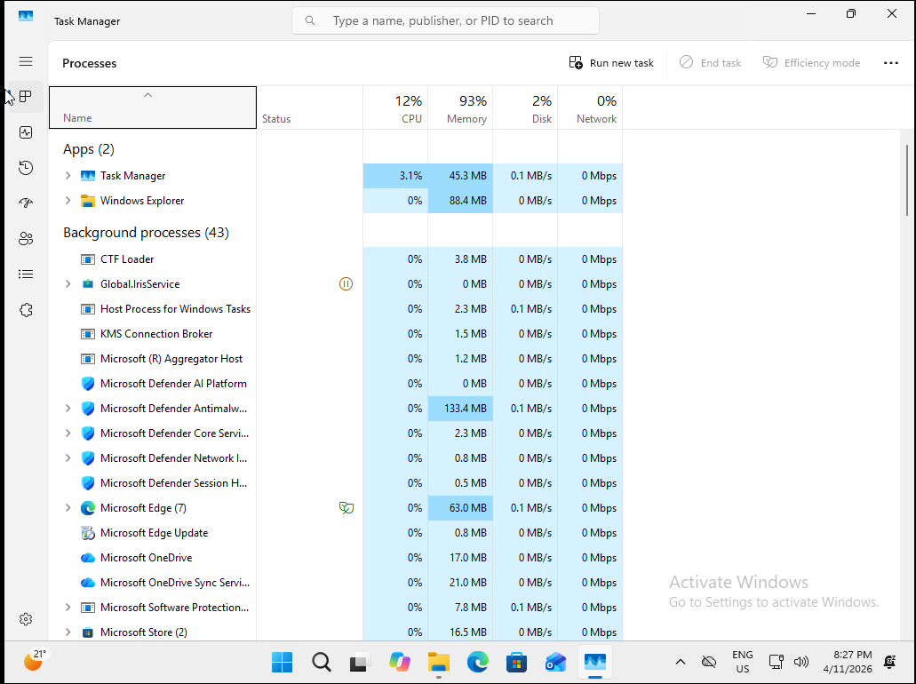
Purpose:
To investigate system resource utilisation and identify whether high CPU, memory or disk usage could contribute to slow Windows startup and reduced system performance.
Investigation performed:
Opened Task Manager on the affected Windows 11 virtual machine. Reviewed the CPU, Memory and Disk utilisation under the Processes and Performance sections.
Result:
Task Manager displayed high CPU and memory utilisation during the investigation. This indicated that the virtual machine was experiencing elevated resource consumption at the time of testing.
Evidence:
Screenshot captured from Task Manager showing high CPU and memory utilisation.
Troubleshooting consideration:
High CPU and memory utilisation can affect system responsiveness and startup performance. Further investigation of running processes and resource consumption is required to identify the applications or services contributing to the issue.

- Identify applications consuming excessive system resources.
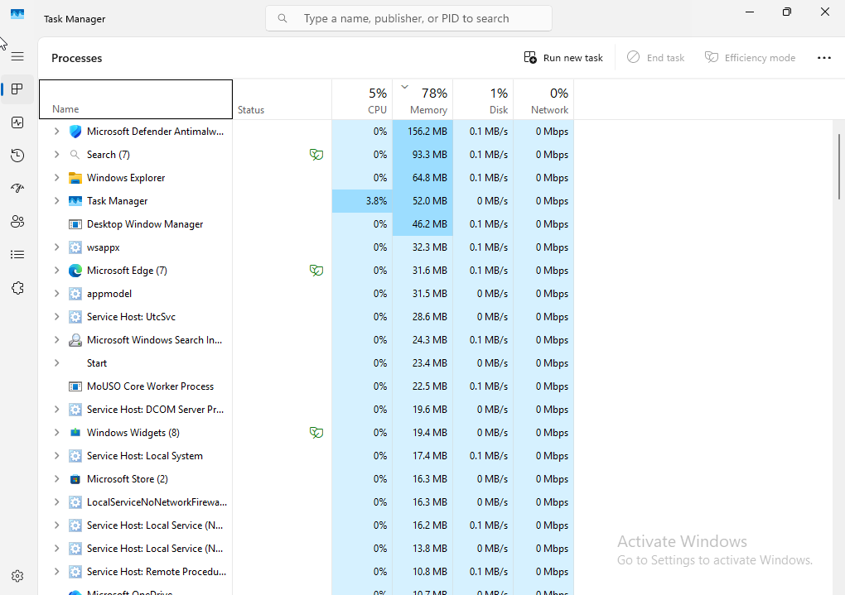
Purpose:
To identify applications and background processes consuming significant system resources and determine potential contributors to poor system performance.
Investigation performed:
Opened Task Manager on the Windows 11 virtual machine and reviewed the Processes section. Sorted the running processes by memory utilisation, from highest to lowest, to identify applications consuming the most RAM.
Result:
Windows Defender Antivirus Service (Antimalware Service Executable) was identified as the process consuming the highest amount of memory during the investigation.
Evidence:
Screenshot captured from Task Manager showing running processes sorted by memory utilisation, with Windows Defender Antivirus Service at the top.
Troubleshooting consideration:
Windows Defender is a built-in Windows security component responsible for antivirus protection. Its elevated memory consumption may be associated with background security activities, such as scanning. Further investigation is required to determine whether its resource usage is temporary or contributing to the reported performance issue. Security protection should not be disabled as a troubleshooting measure.

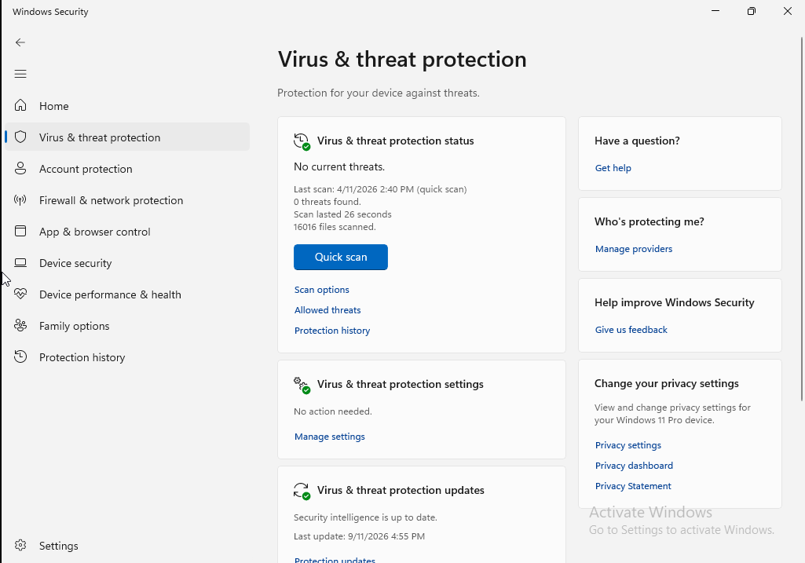

Step 4 – Checked Windows Defender Scan Activity
Purpose:
To determine whether an active Windows Defender antivirus scan was contributing to the high memory utilisation observed in Task Manager.
Investigation performed:
Opened Windows Security → Virus & threat protection and reviewed the current scan activity and previous scan information.
Result:
No antivirus scan was running at the time of investigation. The previous scan had been completed several days earlier.
Evidence:
Screenshot captured from Windows Security showing the scan status and previous scan information.
Troubleshooting consideration:
An active antivirus scan was not identified as the reason for the high memory utilisation during the investigation. Further investigation of Windows Defender's background activity and other system processes may be required.

- Review startup applications.
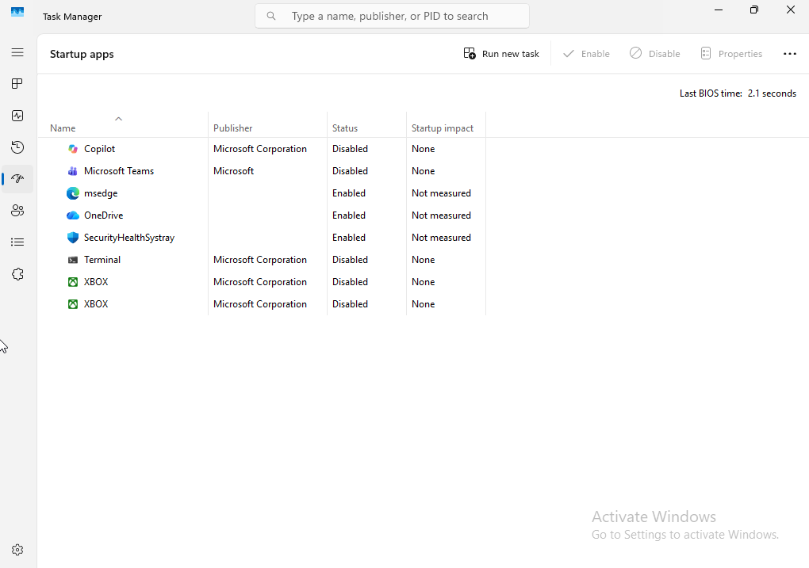

Purpose:
To identify applications configured to launch automatically when Windows starts and determine whether startup applications could contribute to slow startup performance.
Investigation performed:
Opened Task Manager → Startup apps and reviewed the list of applications configured to run during Windows startup. Checked their enabled or disabled status and startup impact.
Result:
Windows Security notification icon (SecurityHealthSystray) was identified as an enabled startup application.
Evidence:
Screenshot captured from Task Manager showing the Startup apps list and SecurityHealthSystray enabled status.
Troubleshooting consideration:
SecurityHealthSystray is a legitimate Windows Security component responsible for displaying security notifications. It should remain enabled. Further investigation is required to identify whether other startup applications contribute to slow startup performance.

- Check available disk space.

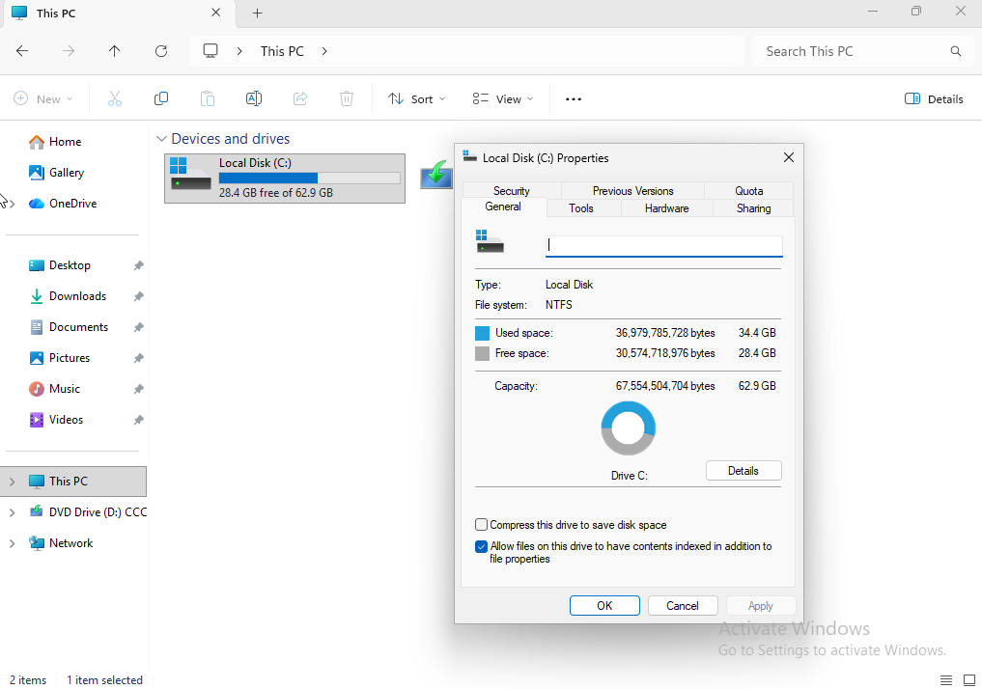

Purpose:
To check whether insufficient disk space could be contributing to slow Windows 11 performance or startup.
Investigation performed:
- Opened File Explorer inside the Windows 11 virtual machine.
- Navigated to This PC.
- Checked the storage capacity and available space on Local Disk (C:).
- Recorded the following results:
Storage information | Result
Total capacity | 62.9 GB
Used space | 34.4 GB
Available free space | 28.4 GB
Free space percentage | Approximately 45%
Result:
The C: drive has approximately 28.5 GB of available space. There is sufficient free storage, and low disk space is unlikely to be the cause of the reported performance issue.
Evidence:
Screenshot: Disk availability.png
Troubleshooting consideration:
If available disk space were critically low, I would investigate temporary files, unnecessary applications and Windows temporary files before considering further storage cleanup. I would avoid deleting user files without permission.

- Review Windows Update status.
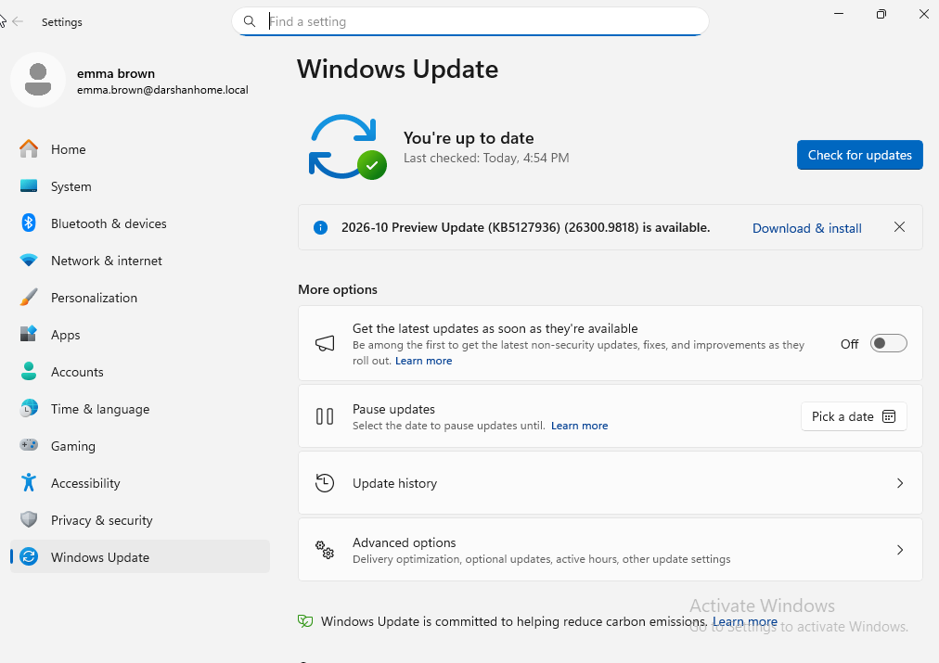

Purpose:
To determine whether pending Windows updates, installation activity or restart requirements could be contributing to slow Windows startup.
Investigation performed:
- Opened Settings.
- Navigated to Windows Update.
- Reviewed the current update status.
- Identified an available optional Preview Update labelled "Download and install".
- Confirmed that the update had not yet been installed.
Result:
Windows Update displayed an optional Preview Update available for download and installation. No evidence was identified that an update was actively installing or that a restart was pending.
Evidence:
Screenshot: Windows Update.png
Troubleshooting consideration:
An available optional update does not necessarily cause slow startup. Before installing updates as part of troubleshooting, I would review their status and any reported errors. I would also avoid installing optional preview updates unnecessarily on a production workstation.

- Check for application or system errors using Event Viewer.
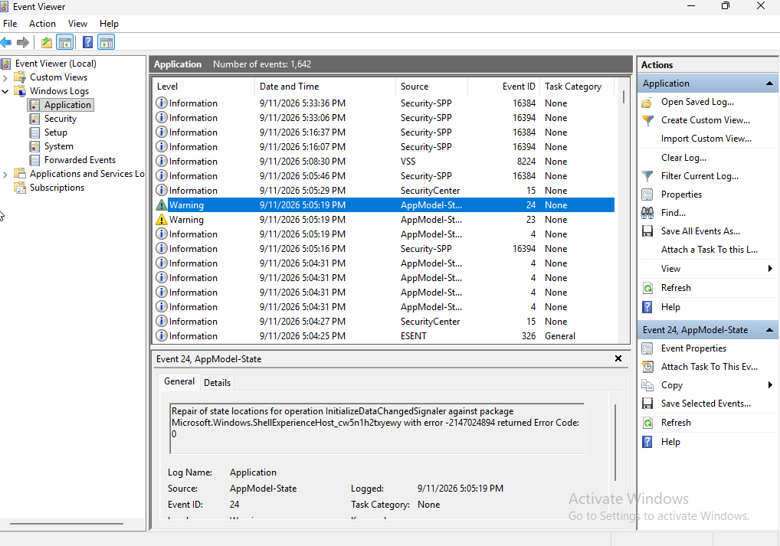

Additional Event Viewer Investigation – Application Warning
Event details:
- Log: Windows Logs → Application
- Source: AppModel-State
- Event ID: 24
- Level: Warning
- Message: Repair of state location for operational initialised data changed.
- Timing: Shortly after user sign-in.
Finding:
An AppModel-State warning was recorded shortly after sign-in. This indicates Windows reported an application-state management event.
Assessment:
The warning has not been confirmed as a cause of slow startup. Further investigation is required to determine whether it is associated with an application issue or the reported performance problem.
Evidence:
Screenshot: eventviewer application.png

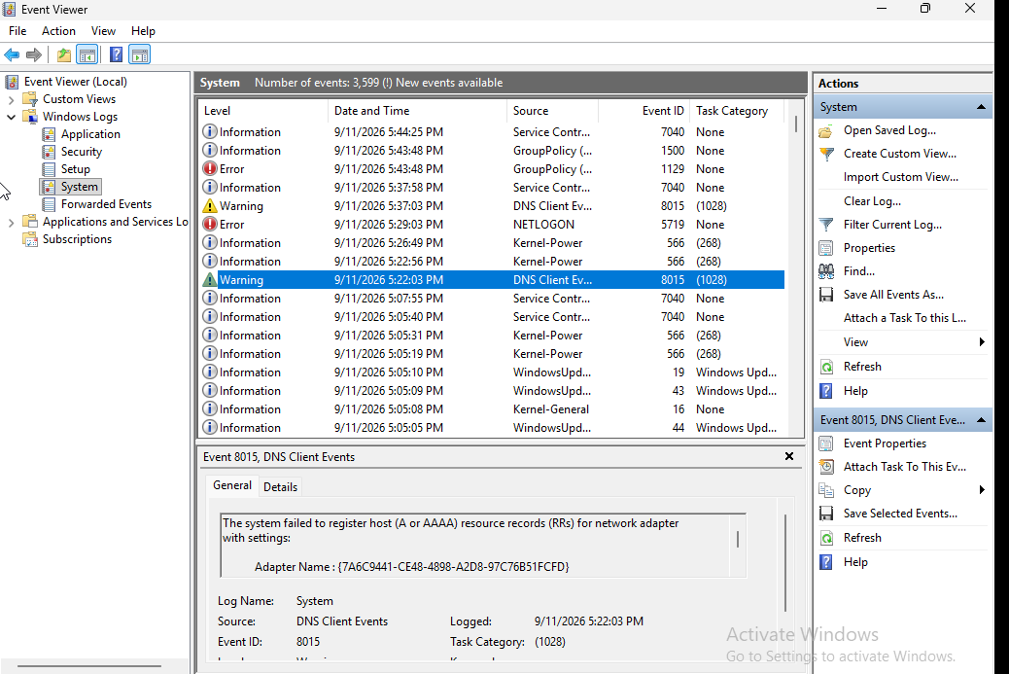

Additional System Log Investigation – Group Policy Connectivity Error
Event details:
- Log: Windows Logs → System
- Source: GroupPolicy
- Event ID: 1129
- Level: Error
- Logged: 09/11/2026 at 5:43:48 pm
- Message: Failed to process Group Policy due to lack of connectivity.
Finding:
Windows recorded a Group Policy processing failure because the workstation could not establish the required network connectivity.
Potential causes:
- Domain Controller unavailable.
- Network connectivity issues.
- DNS configuration problems.
- Network services not ready during Group Policy processing.
Assessment:
This event may be relevant to the reported startup or sign-in delay. Further investigation is required to identify the underlying cause.
Evidence:
Screenshot: Eventviewersystem.png

- Review Windows system performance and Reliability Monitor.
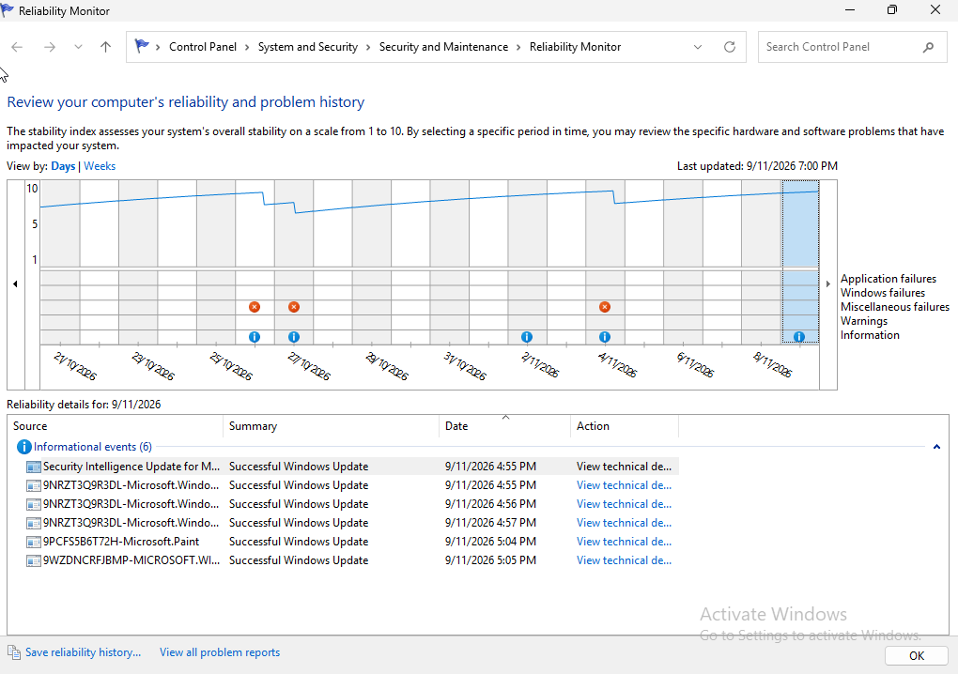
Step 8 – Review Windows System Performance and Reliability Monitor
Purpose:
To identify application failures, Windows errors, unsuccessful installations or other reliability issues that could contribute to slow system startup.
Investigation performed:
- Opened Reliability Monitor using perfmon /rel.
- Reviewed the reliability history for the current date.
- Examined the six events displayed.
- Identified all six as successful application installation events, represented by blue informational symbols.
Result:
All six recorded installation events were successful. No application crash was identified from the events reviewed.
Assessment:
The reviewed events did not provide evidence of application installation failures contributing to slow startup.
Troubleshooting consideration:
If application failures or critical events were identified, I would investigate their technical details, timestamps and frequency before determining whether they were related to the reported performance issue.

- Apply appropriate corrective actions.
Purpose:
To restore communication between the Windows 11 workstation and the Active Directory Domain Controller and verify successful Group Policy processing.
Problem identified:
Event Viewer recorded GroupPolicy Event ID 1129, indicating that Group Policy processing failed because of a lack of network connectivity.
Further investigation established that the Domain Controller was switched off when the Windows 11 VM started.
Corrective actions performed:
- Started the Windows Server laptop hosting the Domain Controller.
- Confirmed that the Domain Controller was available on the network.
- Tested connectivity to the Domain Controller using ping 192.168.1.16.
- Verified DNS resolution using nslookup.
- Executed gpupdate /force to refresh computer and user Group Policy settings.
- Executed gpresult /r to review the applied Group Policy information.
Result:
The Domain Controller became available, and connectivity, DNS resolution and Group Policy processing were verified using the above troubleshooting commands.

Evidence:
- Scenario-ping damoin controller.png
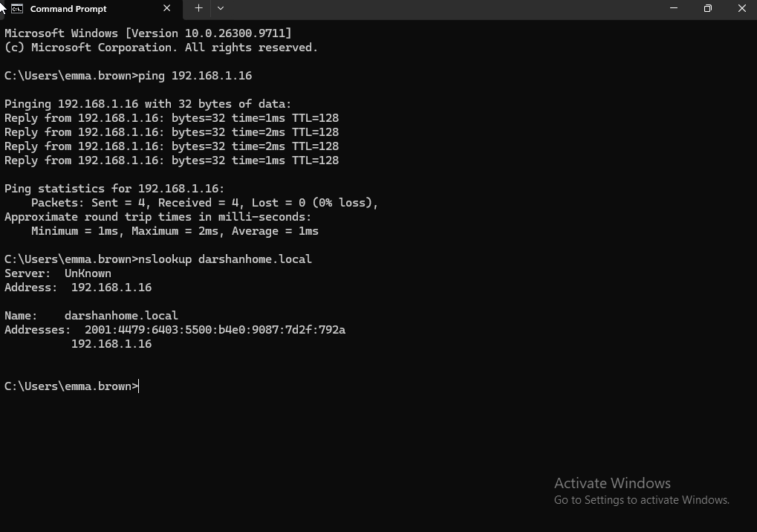

- Scenario-gpupdate force.png
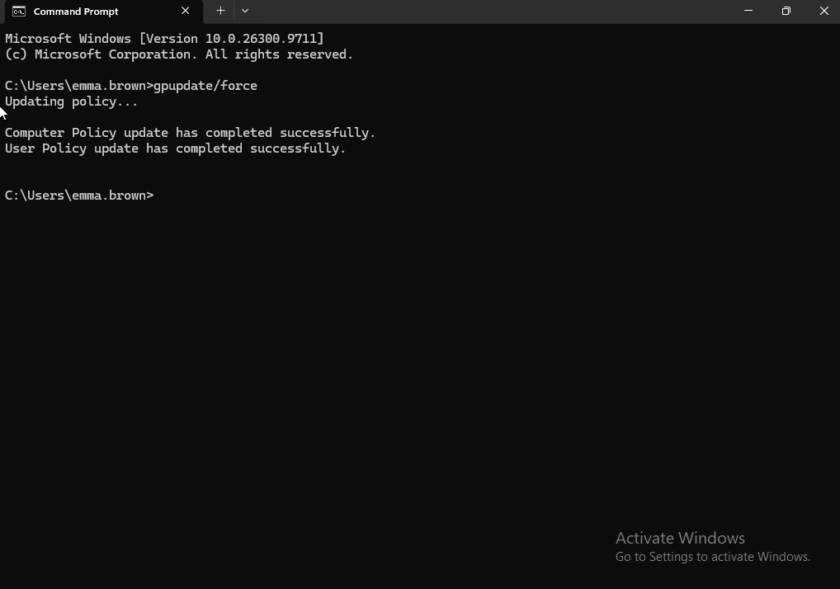
- Scenario-gpresultr result1.png
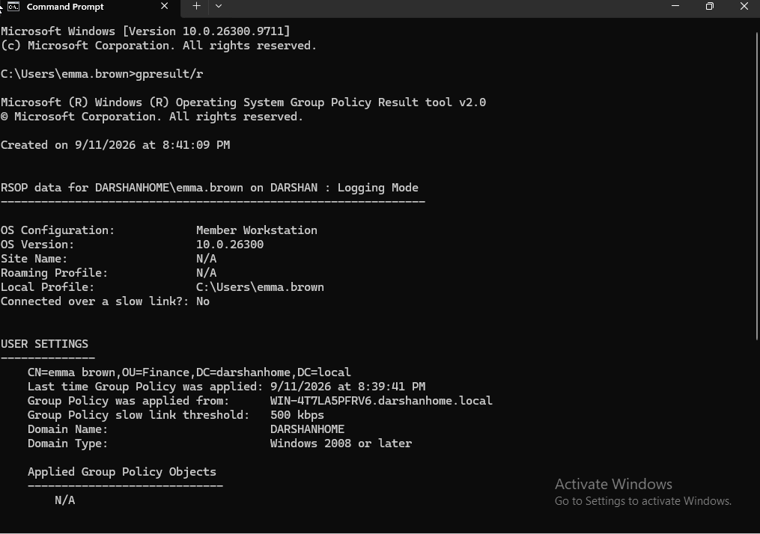
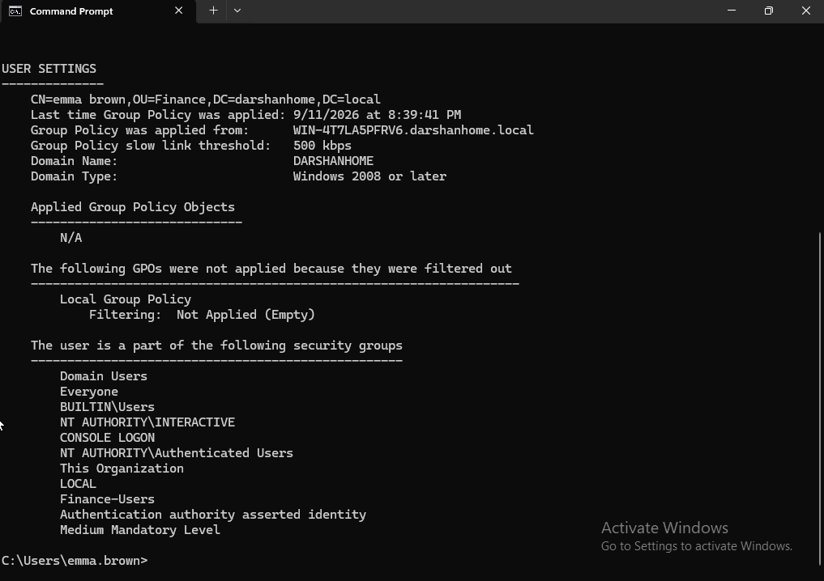
Troubleshooting conclusion:
The unavailable Domain Controller was identified as the cause of the Group Policy connectivity error. Restoring Domain Controller availability allowed the workstation to communicate with the domain infrastructure and process Group Policy successfully.
Further consideration:
A separate startup performance comparison is required to determine whether restoring domain connectivity improved the overall Windows startup experience.

- Verify system performance after troubleshooting.
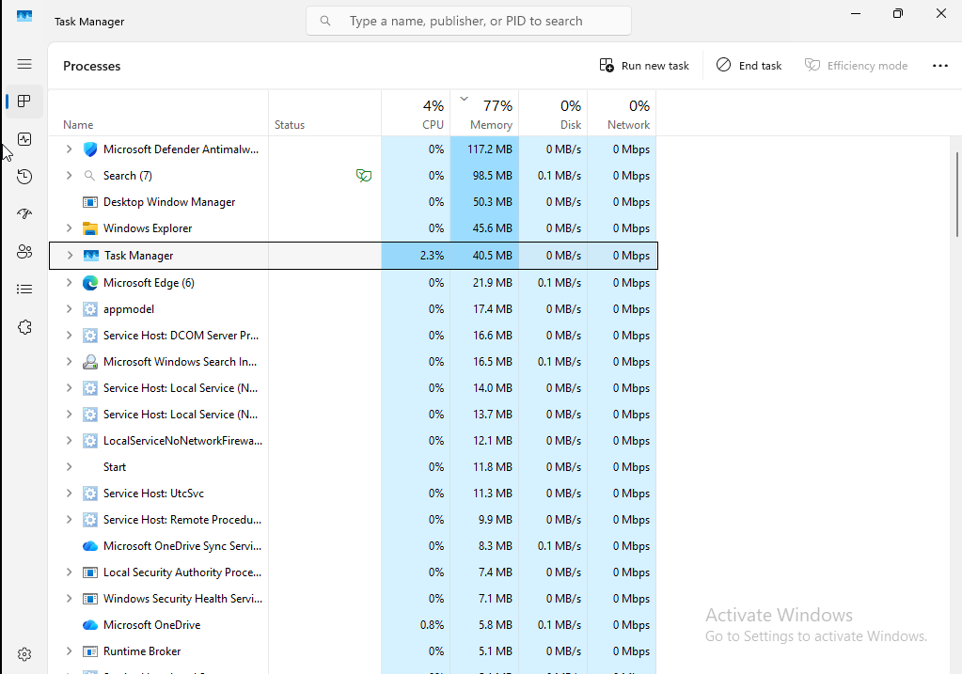
Part 1 –Review CPU and Memory Utilisation
Purpose:
To assess system resource utilisation after completing the corrective actions.
Investigation performed:

- Reviewed CPU and memory utilisation.
- Recorded the following results:
Resource | Utilisation
CPU | 4%
Memory | 77%
Result:
CPU utilisation was 4%, indicating relatively low processor activity. Memory utilisation was 77%, which did not independently indicate critical memory pressure.
Assessment:
The workstation showed reasonable CPU and memory utilisation at the time of observation. Further checks are required to assess disk activity and startup performance.

11 .Windows Startup Performance Analysis
Objective:
Measure Windows 11 startup performance after completing the troubleshooting activities.
Investigation performed:
- Opened Event Viewer with administrator privileges.
- Navigated to Microsoft → Windows → Diagnostics-Performance → Operational.
- Located the latest Windows Boot Performance event (Event ID 100).
- Opened the event's Details tab and reviewed the startup performance measurements.
Results:
Performance metric | Recorded value
Boot Time | 38,863 ms (38.86 seconds)
Main Path Boot Time | 11,063 ms (11.06 seconds)
Boot Post Boot Time | 27,800 ms (27.80 seconds)
Analysis:
Windows recorded a total boot time of approximately 38.86 seconds. The main boot path accounted for approximately 11.06 seconds, while post-boot activities accounted for approximately 27.80 seconds.
The measurements provide a baseline for assessing startup performance. Although Windows completed its startup process, the post-boot period was longer than the main boot path.
The available evidence does not establish that the Group Policy connectivity issue was the sole cause of the original slow startup.
Outcome:
A new Windows startup performance event was successfully generated and reviewed after the troubleshooting activities. The recorded measurements were captured for comparison and future investigation.
Evidence:
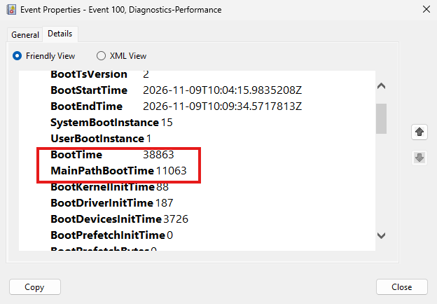

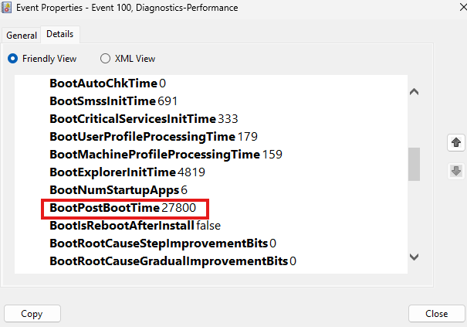

3. Expected Outcome
- Identify potential causes of slow Windows 11 startup and performance.
- Identify resource-intensive processes using Task Manager.
- Review startup applications and determine whether unnecessary applications are affecting startup.
- Check available disk space and Windows Update status.
- Investigate relevant Windows errors and warnings using Event Viewer and Reliability Monitor.
- Identify and resolve domain connectivity or Group Policy processing issues where applicable.
- Verify connectivity to the Domain Controller and confirm successful DNS resolution and Group Policy processing.
- Measure Windows startup performance using the Diagnostics-Performance Event ID 100.
- Confirm whether the troubleshooting actions improved system performance without compromising Windows security or functionality.
- Document the investigation, corrective actions, results and supporting screenshots.

4.Resolution and Closure

Resolution:
The investigation identified a Domain Controller connectivity issue affecting Group Policy processing on the Windows 11 workstation.
The Windows Server laptop hosting the Domain Controller was switched on to restore domain connectivity.
The following verification activities were performed:
- Confirmed network connectivity between the Windows 11 workstation and the Domain Controller.
- Verified DNS configuration and domain name resolution.
- Successfully discovered the Domain Controller.
- Executed gpupdate /force to refresh Group Policy settings.
- Used gpresult /r to review the applied Group Policy information.
- Reviewed Task Manager to assess CPU and memory utilisation.
- Reviewed Windows startup performance using Event Viewer (Diagnostics-Performance Event ID 100).

Verification Results:
- Domain Controller connectivity was restored.
- DNS resolution was verified.
- Group Policy processing was successfully refreshed and reviewed.
- A new startup performance event was recorded, showing a total boot time of 38.86 seconds.
- Main Path Boot Time was 11.06 seconds.
- Boot Post Boot Time was 27.80 seconds.

Closure Status:
The Domain Controller connectivity and Group Policy processing issue was resolved and verified.
However, the original slow-startup complaint has not been conclusively resolved because there is insufficient comparative startup performance evidence to confirm an improvement.
The incident should therefore remain open for further performance monitoring or be closed only if the simulated user confirms that startup performance is now acceptable.

Final Status: Partially resolved – Domain connectivity and Group Policy issue resolved; overall startup performance improvement not yet confirmed.

Scenario 4 – Windows Update problems
Incident INC-004 – Windows Update Failure
Issue: Windows Update fails to install a cumulative update.
User: Emma Brown
Department: Finance
Device: Windows 11 Workstation
Category: Windows 11 – Windows Update
Priority: P3 – Medium
Status: Open – In Progress
Description:
The user reports that their Windows 11 workstation repeatedly fails to install a cumulative Windows update. The update installation starts but does not complete successfully.
The user has attempted to install the update multiple times, but the issue persists. Windows Update continues to display an installation error.
User Impact:
The user can continue using the workstation; however, the device may be missing an important Windows security update.
Troubleshooting Required:
- Identify the affected workstation and logged-in user.
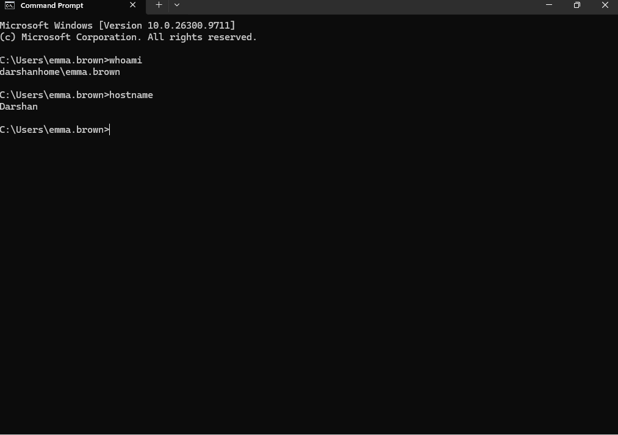
Screenshot Evidence:
Scenario-userconfirmation.png

Action Performed:
- Executed whoami in Command Prompt to identify the currently logged-in user.
- Executed hostname to identify the affected workstation.
Result:
- Successfully identified the logged-in user account.
- Successfully identified the workstation name.
- Confirmed the correct user and device before proceeding with troubleshooting.

- Check Windows Update history.
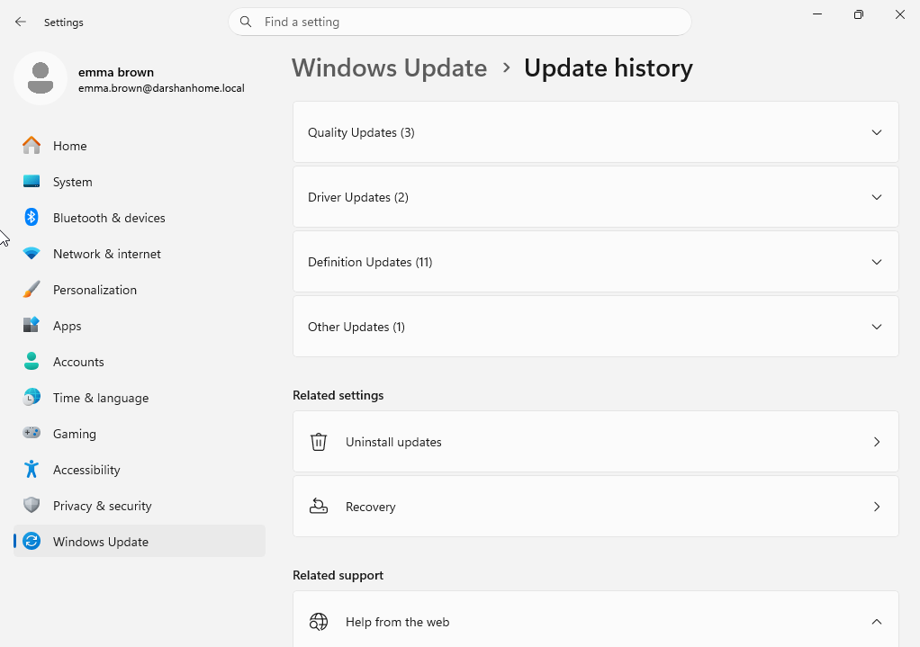
Screenshot Evidence:
Scenario-windowsupdatehistory.png

Action Performed:
- Navigated to Settings → Windows Update → Update history.
- Reviewed the Windows Update history to identify previously installed and failed updates.
- Checked the update records for relevant installation details.
Result:
- Successfully accessed Windows Update history.
- Reviewed the available update records.
- Identified the update information for further investigation.

- Record the update KB number.
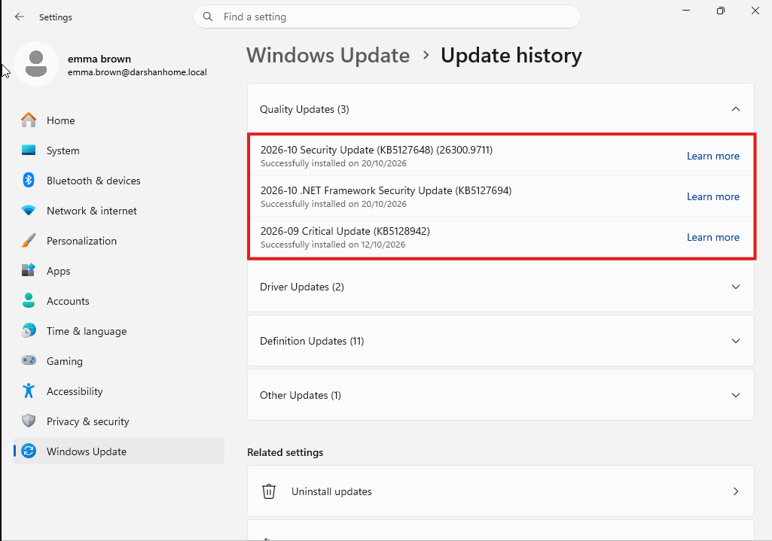
Scenario-kbnumber.png
Action Performed:
- Reviewed the Windows Update history.
- Identified three updates with their corresponding Knowledge Base (KB) numbers.
- Recorded the KB numbers for further investigation.
Result:
- Successfully identified three Windows updates.
- Collected the KB reference numbers for tracking and troubleshooting.
Screenshot Evidence:

- Record the exact error code and failure date.
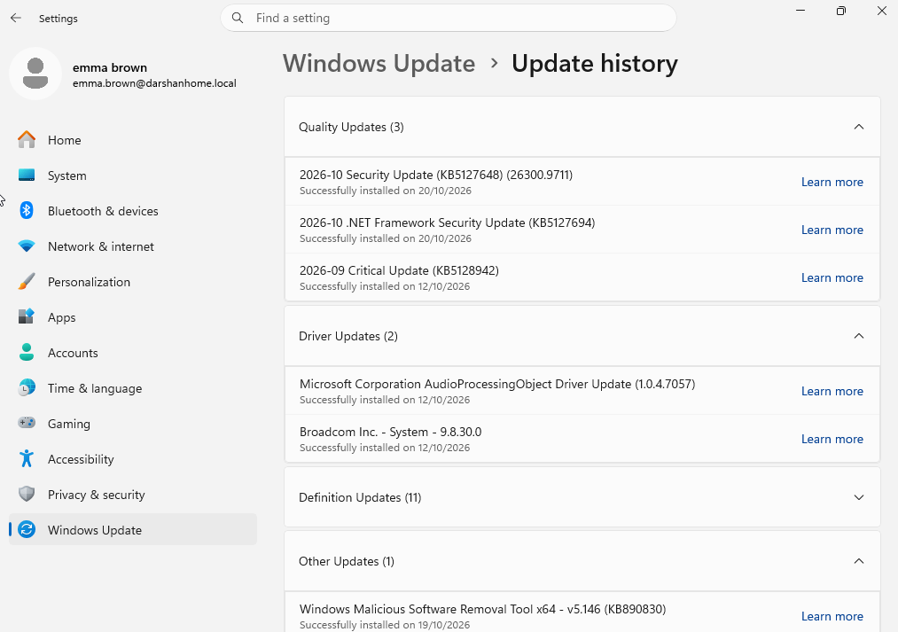
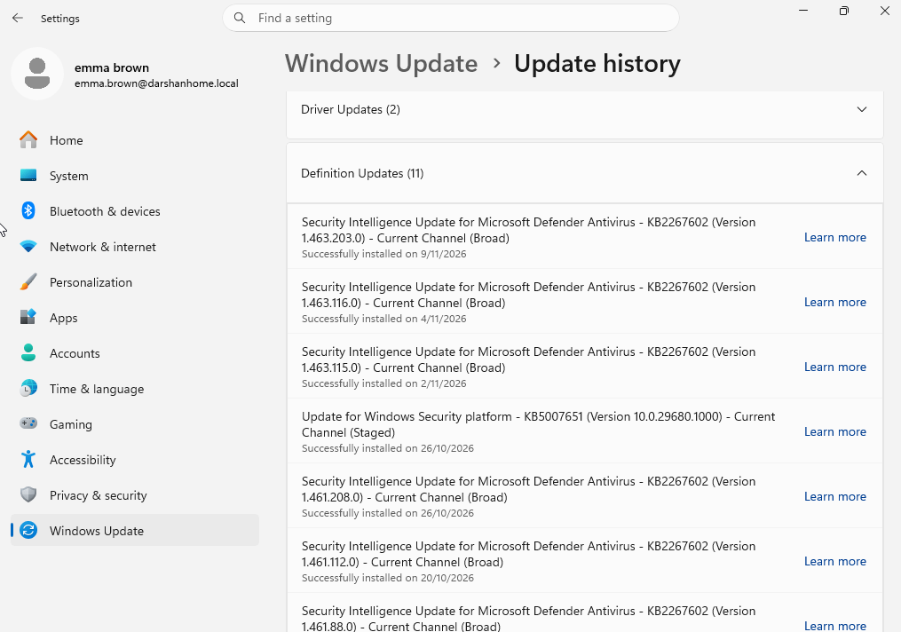
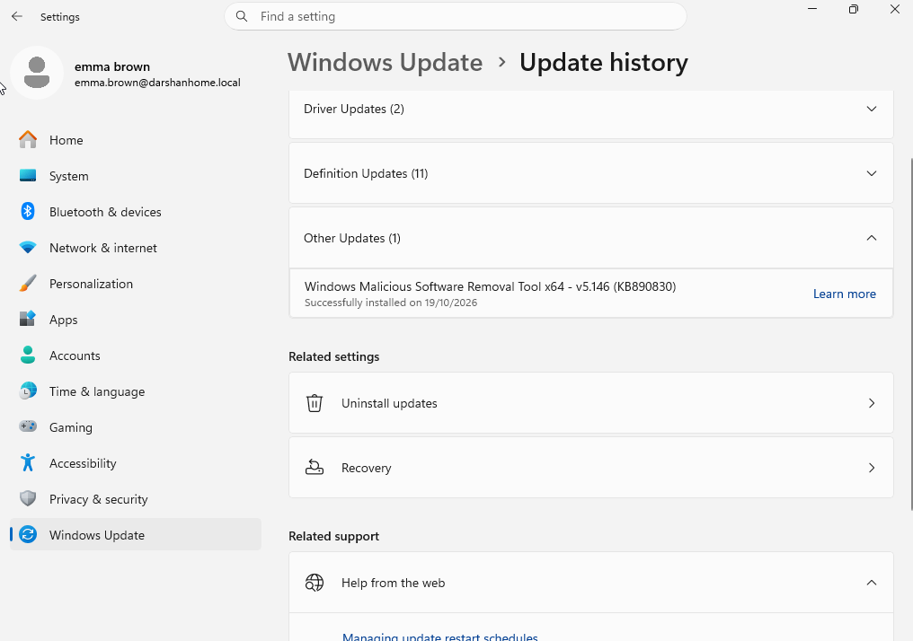

Action Performed:
- Reviewed Windows Update history to identify any unsuccessful installation attempts.
- Checked the available update records for error codes and failure dates.
Result:
- No failed Windows Update installations were identified.
- No Windows Update error codes or failure dates were available to record.
- Further troubleshooting of a failed update could not be performed because no failure was present.

- Check whether a restart is pending or has already occurred.
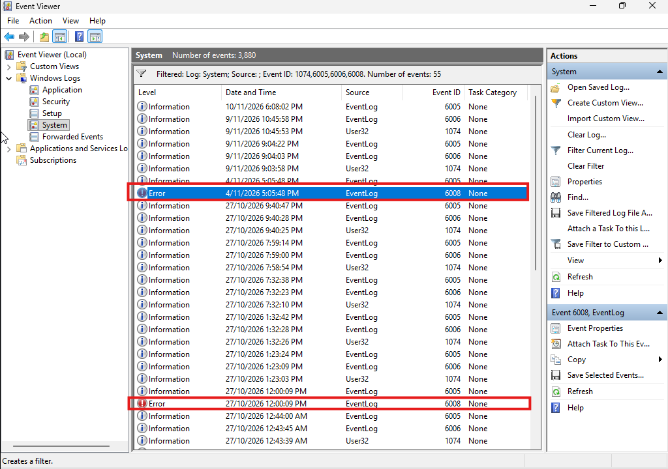
Screenshot Evidence:eventviewer.png

Action Performed:
- Reviewed Windows Update settings for pending restart notifications.
- Checked Windows Event Viewer under Windows Logs → System.
- Identified several unexpected shutdown events.
Result:
- Several unexpected shutdown events were identified in Event Viewer.
- These events confirm previous unexpected shutdowns.
- No evidence has yet established that these shutdowns were related to Windows Update.
- Pending restart status requires separate verification.

- Check available disk space and Windows Update service status.
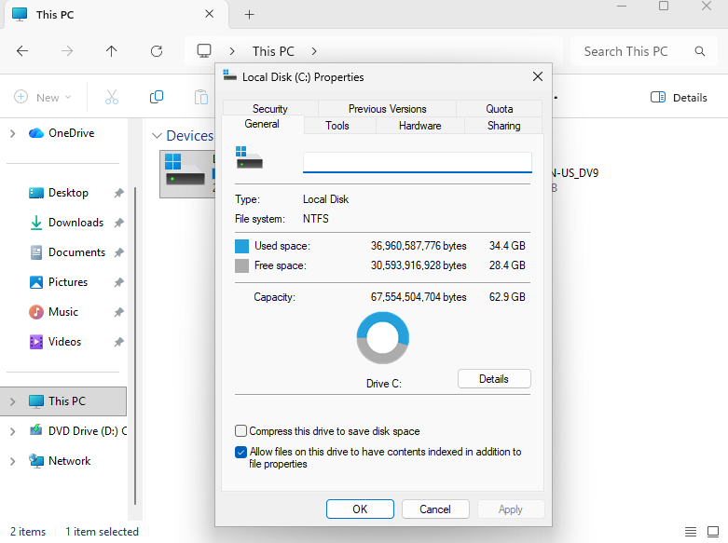

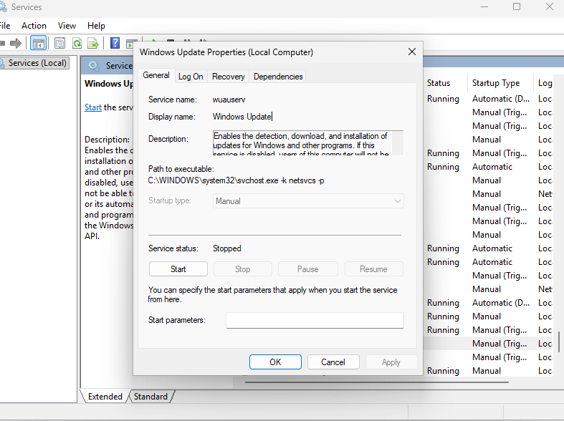
Action Performed:
- Checked the available disk space on the Windows system drive.
- Reviewed the current status of Windows Update-related services.
- Captured the disk availability and service status for further investigation.
Result:
- Successfully verified the available storage space on the workstation.
- Checked the current status of Windows Update services.
- Collected evidence to help determine whether insufficient disk space or service-related issues could affect Windows Update operations.

- Investigate the error and apply an appropriate fix.
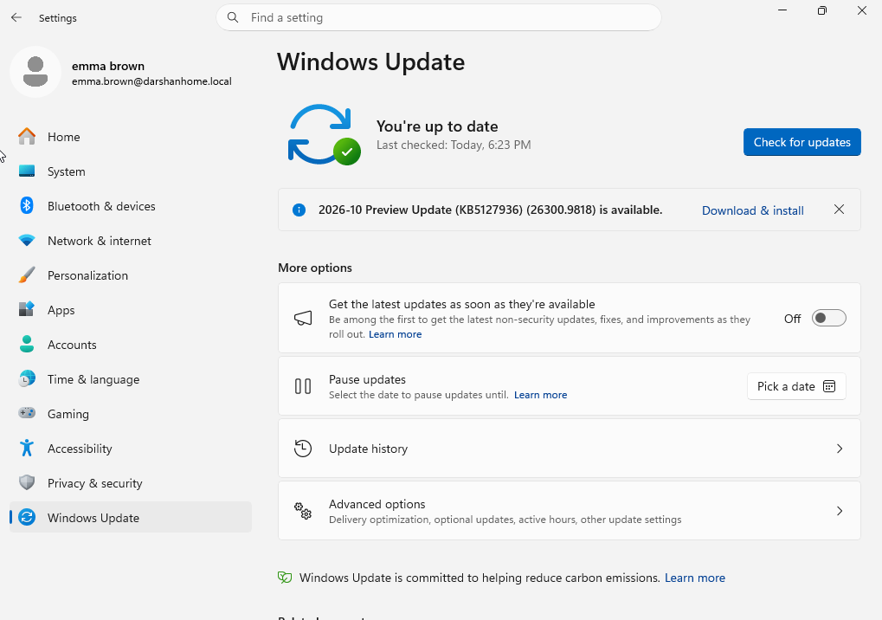
Action Performed:
- Reviewed Windows Update history for failed installations.
- Checked for Windows Update error codes and failure dates.
- Reviewed relevant Windows Update service status and available system disk space.
- Investigated the available evidence to identify a possible cause.
Result:
- No failed Windows Update installations or error codes were identified.
- No specific Windows Update fault was found that required a fix.
- No changes were made to the system because there was no confirmed issue to resolve.

Scenario 5 – Application not opening or crashing
INC-005 – Application Not Opening or Crashing
Open – In Progress
Field | Details
User | Sarah Jones
Department | IT
Device | Windows 11 workstation
Category | Application / Software Troubleshooting
Priority | P3 – Medium
Assigned to | Level 1 IT Support
Status | Open – In Progress
User-reported issue
The user reports that VLC player does not open correctly. When attempting to launch VLC Player, the application either closes unexpectedly or becomes unresponsive.
Business impact
The user is currently unable to access VLC Player to complete normal finance-related tasks. Other applications appear to be working normally, but this needs to be confirmed.

Initial troubleshooting notes
- Confirm the affected user and workstation.
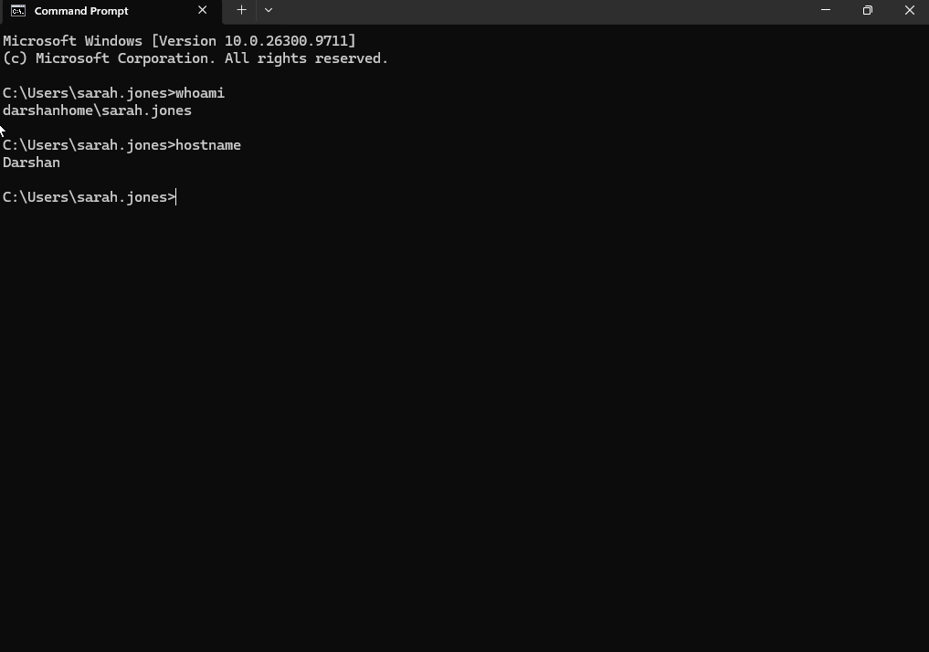

Action Performed:
- Executed whoami in Command Prompt to identify the currently logged-in user.
- Executed hostname to identify the workstation.
Result:
- Successfully identified the logged-in user and workstation.
- Confirmed the correct user account and device before proceeding with troubleshooting.

- Identify the application version.
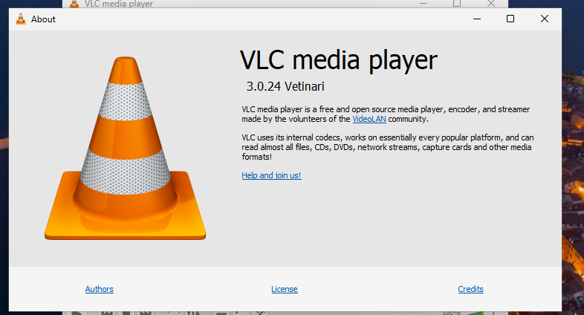
Action Performed:
- Opened VLC Media Player.
- Navigated to Help → About.
- Checked the installed application version.
Result:
- Successfully identified the installed VLC Media Player version.

- Check whether VLC Player is running in the background.
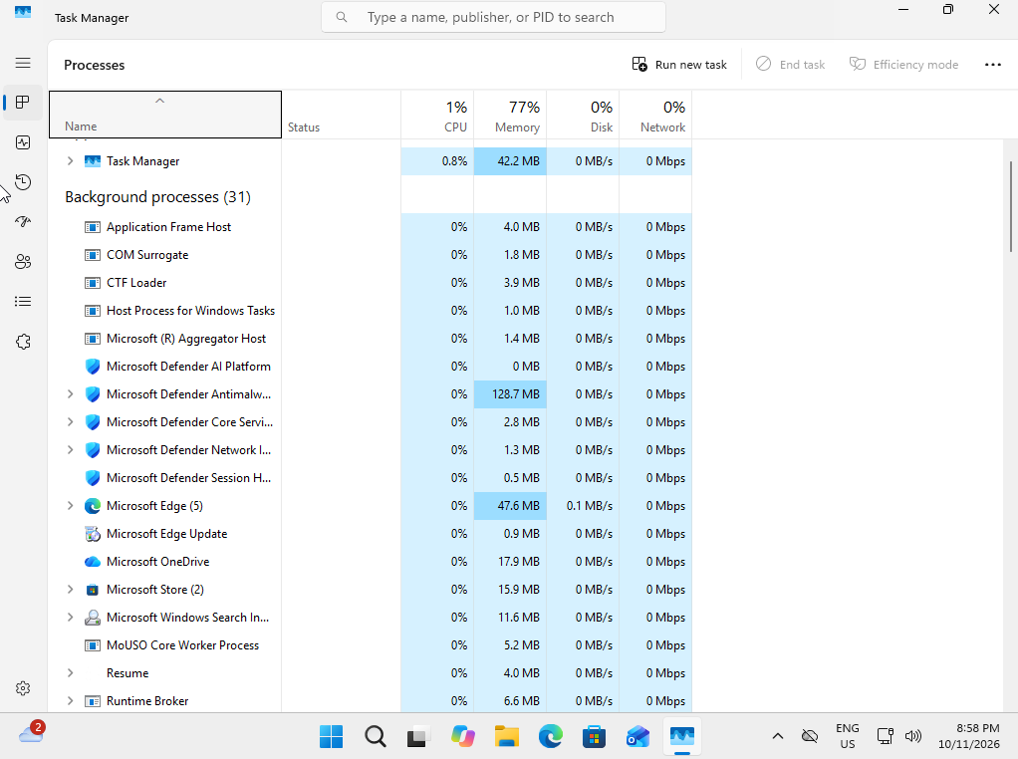
Action Performed:
- Opened Task Manager using Ctrl + Shift + Esc.
- Navigated to the Processes section.
- Reviewed the background processes to check whether VLC Media Player was running.
Result:
- Checked the running processes for VLC Media Player.
- Recorded whether vlc.exe was present in the background. =Not Running in the Background

- Review application errors in Event Viewer and Reliability Monitor.
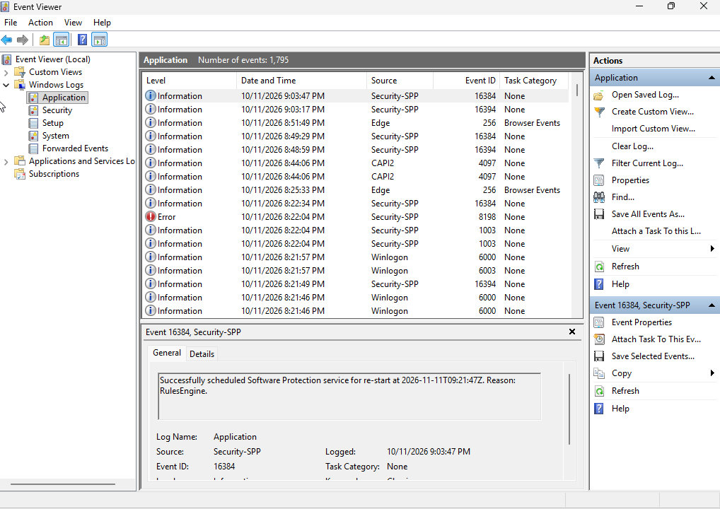

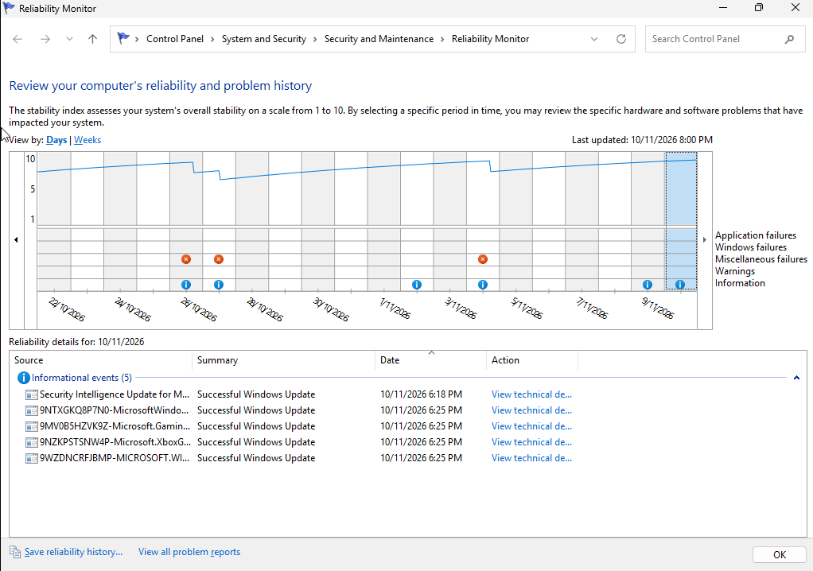

Action Performed:
- Opened Reliability Monitor and reviewed application reliability events.
- Opened Event Viewer → Windows Logs → Application.
- Checked for VLC-related application errors and crash events.
Result:
- No VLC-related application crashes or errors were identified.
- No relevant issues were recorded in the logs during the period reviewed.

- Check for available updates.
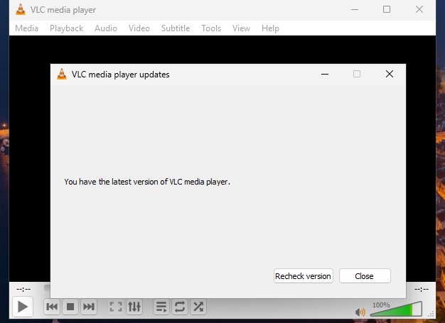
Action Performed:
- Opened VLC Media Player.
- Navigated to Help → Check for Updates.
- Checked whether a newer application version was available.
Result:
- VLC confirmed that the latest version is installed.
- No application update was required.

Expected resolution
- Followed the standard Level 1 application troubleshooting procedures for practice purposes.
- Verified the user, workstation and VLC application version.
- Checked background processes, application logs, Reliability Monitor and available updates.
- No application errors, crashes or other issues were identified.
- VLC Media Player was functioning normally throughout the investigation.
- No repair or reinstallation was required.

Final Ticket Status: Closed – No Fault Found

Scenario 6 – Printer and print queue problems
Incident Ticket – INC-006
Field | Details
Incident ID | INC-006
Issue | Printer and Print Queue Problems
User | Sarah Jones
Department | Finance
Device | Windows 11 Workstation
Printer | Microsoft Print to PDF
Category | Printer / Printing
Priority | P3 – Medium
Status | Open – In Progress
User-reported issue:

The user reports that print jobs are not completing successfully. The print queue may become stuck, preventing documents from being printed.

Business impact:

The user is unable to complete normal printing tasks, potentially affecting daily work.

Troubleshooting objective:

Step 1 – Verify the user and workstation

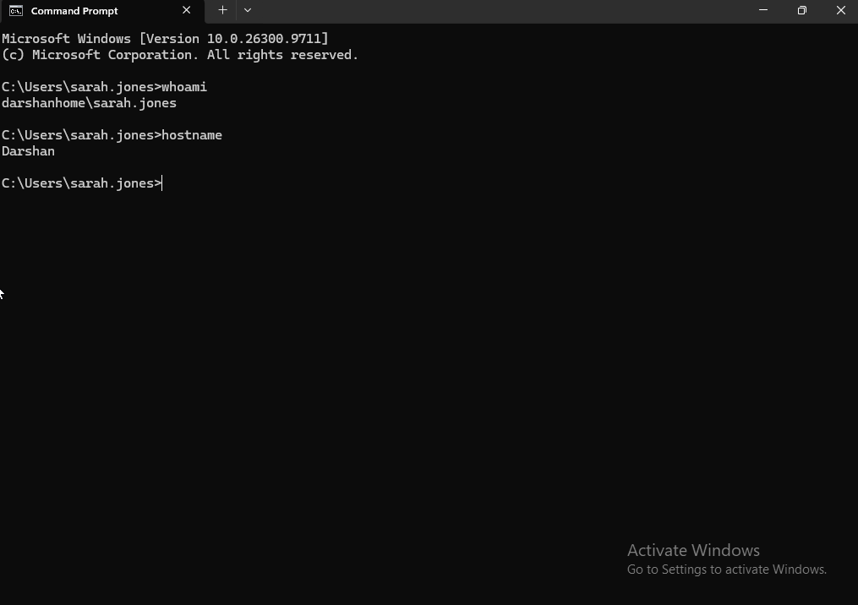
Action Performed:
- Opened Command Prompt.
- Executed whoami to identify the currently logged-in user.
- Executed hostname to identify the workstation.
Result:
- Successfully identified the logged-in user and workstation.
- Confirmed the correct user account and device before proceeding with troubleshooting.

Step 2 – Verify the Installed Printer

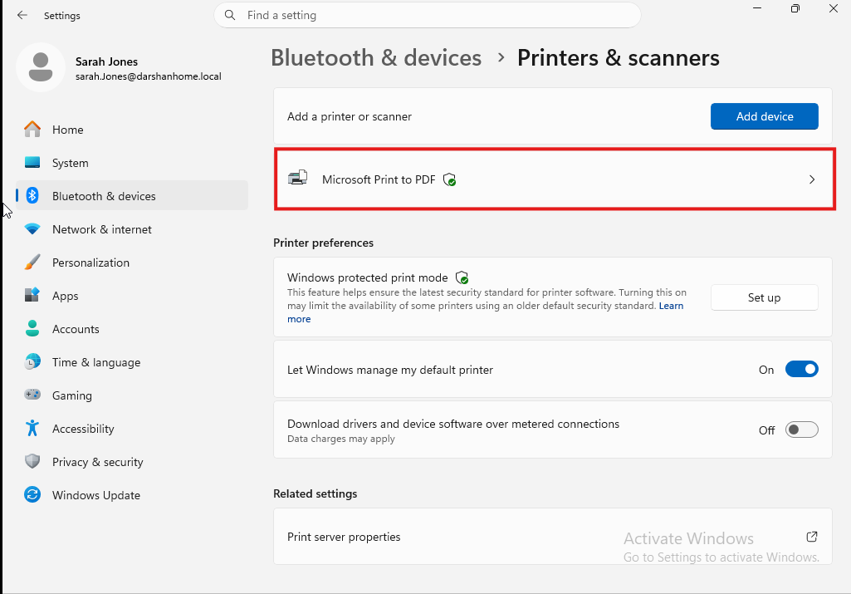

Action Performed:
- Opened Settings → Bluetooth & devices → Printers & scanners.
- Reviewed the list of installed printers.
- Identified Microsoft Print to PDF.
Result:
- Successfully confirmed that Microsoft Print to PDF is installed on the Windows 11 workstation.
- Printer is available for the troubleshooting exercise.

Step 3 – Check the Print Queue

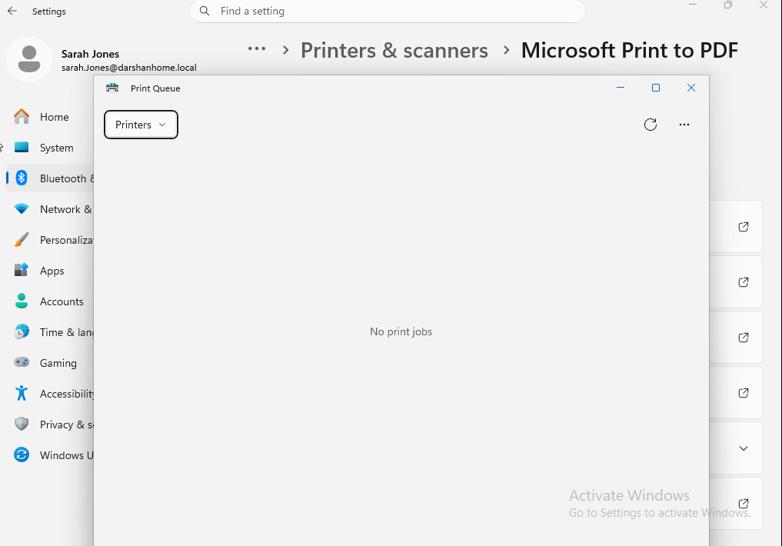

Action Performed:
- Opened Microsoft Print to PDF.
- Selected Open print queue.
- Reviewed the print queue for pending or failed print jobs.
Result:
- Print queue was empty.
- No pending, printing or failed jobs were identified.
- No stuck print jobs were found during the inspection.

Step 4 – Check Print Spooler service
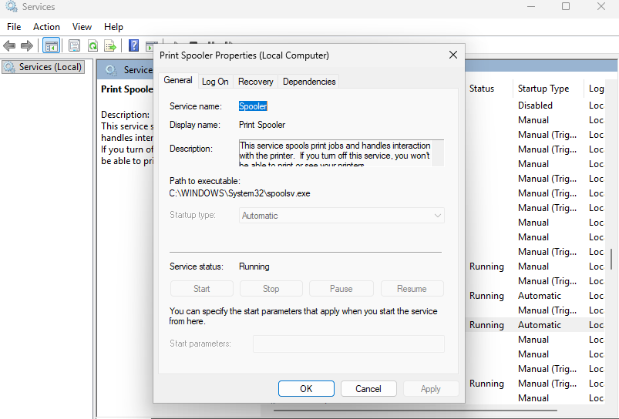

Action Performed:
- Opened Windows Services using services.msc.
- Located the Print Spooler service.
- Checked the current service status.
Result:
- Print Spooler service was running.
- No stopped-service issue was identified during the inspection.

Step 5 – Check Printer Status and Configuration

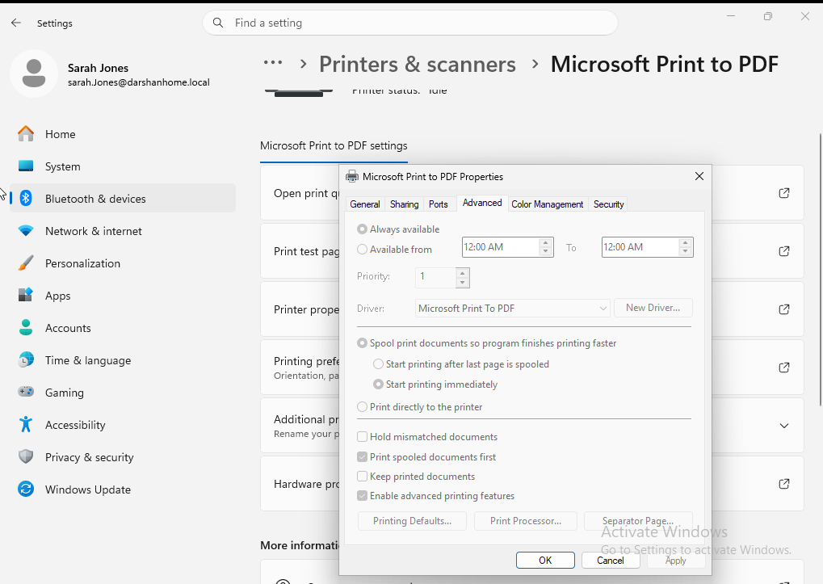

Action Performed:
- Opened Microsoft Print to PDF printer properties.
- Navigated to the Advanced Properties section.
- Reviewed the available printer configuration settings.
Result:
- Successfully accessed the printer's advanced configuration settings.
- Reviewed the available printer properties for potential configuration issues.

Step 6 – Perform a test print



Action Performed:
- Opened Notepad and entered a test message.
- Selected File → Print.
- Selected Microsoft Print to PDF as the destination printer.
- Completed the print process and saved the generated PDF file to the Desktop.
Result:
- Successfully generated and saved the test PDF.
- Confirmed that Microsoft Print to PDF was functioning correctly during the test.
- No printing issue was identified.

Step 7 – Review Findings and Determine Whether a Fix Is Required

Action Performed:
- Reviewed the findings from the previous troubleshooting steps.
- Checked printer installation, print queue, Print Spooler service and printer configuration.
- Reviewed the test-print result to determine whether further troubleshooting was required.
Result:
- Microsoft Print to PDF was installed and available.
- Print queue was empty.
- Print Spooler service was running.
- Test PDF was successfully generated and saved.
- No printer-related errors or faults were identified.
- No corrective action was required.

Final Ticket Outcome:
Closed – No Fault Found

Scenario 7 – Audio, microphone and camera
Step 1 – Verify workstation
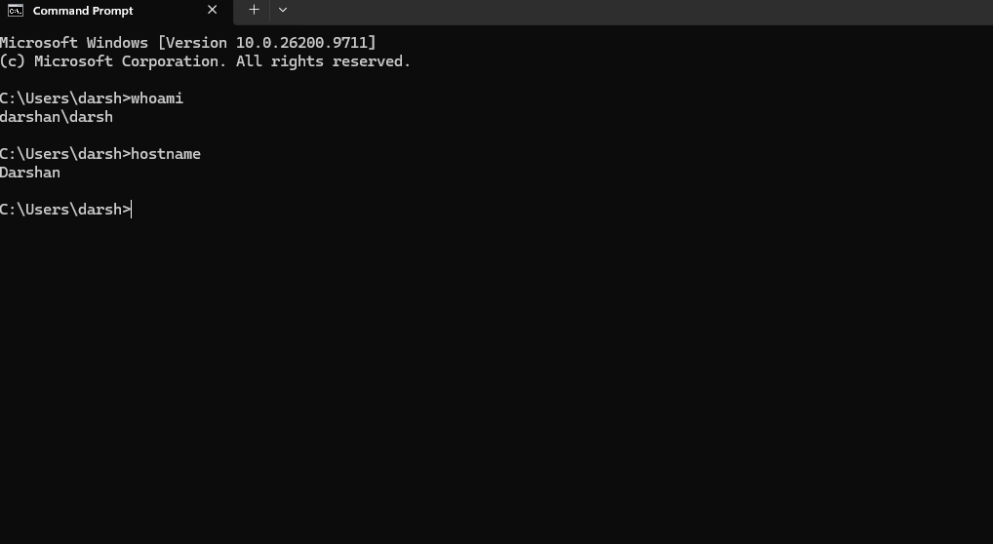

Step 2 – Webcam detection and functionality.
Action Performed:
- Opened Windows Device Manager and checked the webcam.
- Observed that the device was listed but reported as not connected.
- Opened the Windows Camera app and attempted to access the webcam.
- Checked whether changing to a different USB port resolved the issue.
- Connected the webcam to another computer to isolate the issue.
Result:
- Windows Camera app displayed an error when attempting to access the webcam.
- Device Manager showed the webcam entry but reported that the device was not connected.
- Changing the USB port did not resolve the issue.
- Testing on another computer also failed to detect the webcam.
- Suspected webcam hardware or USB cable failure.

Screenshot Evidence:

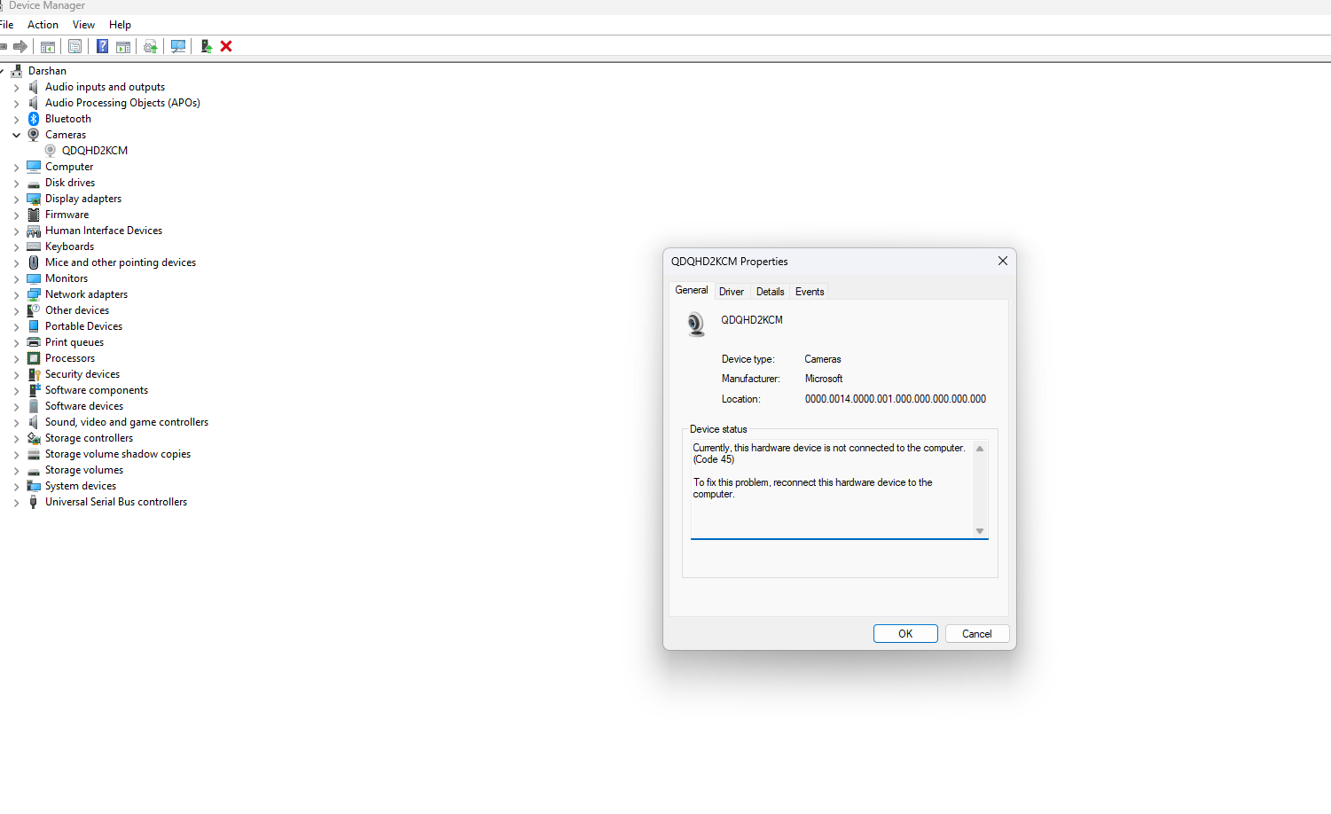



Ticket status: Escalated – Suspected Hardware Fault.

Scenario 8 – Display, monitor and graphics
Incident INC-008 – Display, Monitor and Graphics Issues
Ticket Details
Field | Details
Incident ID | INC-008
User | Sarah Jones
Department | Finance
Device | Windows 11 Workstation
Category | Hardware / Display
Priority | P3 – Medium
Status | Open – In Progress
Assigned To | Level 1 IT Support
User Report
The user reports that their monitor occasionally displays an incorrect screen resolution, making text and application windows appear unusually large. The user also reports that the display sometimes appears blurry after connecting the monitor.
Business Impact
The user can still access Windows and open applications, but the display quality makes it difficult to work comfortably and efficiently.
Initial Troubleshooting Objectives
- Verify the user's identity and workstation.
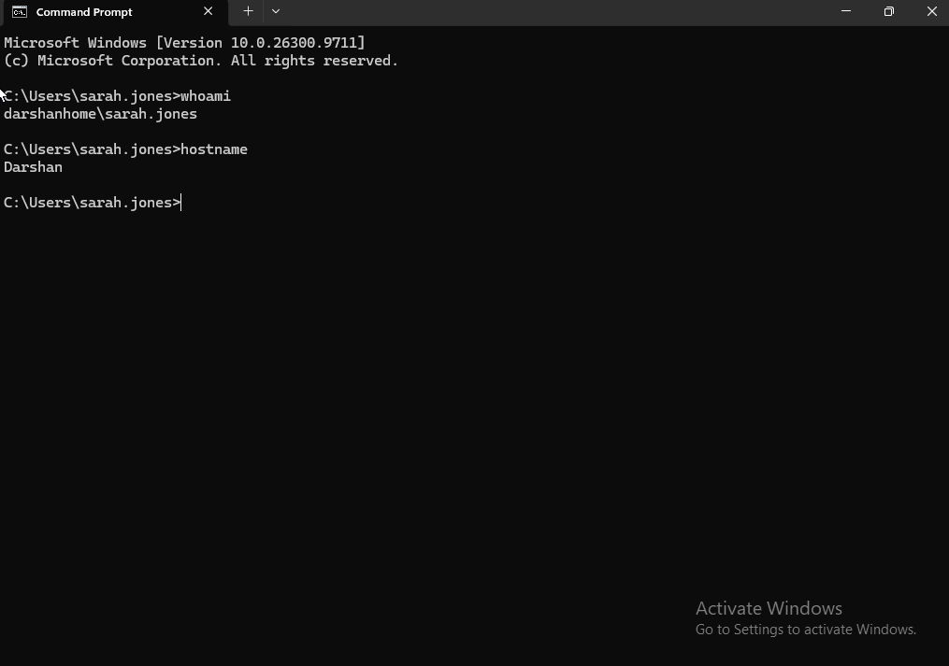

Action Performed:
- Opened Command Prompt.
- Executed whoami to identify the currently signed-in user.
- Executed hostname to identify the workstation.
Result:
- Confirmed the logged-in Windows user account.
- Confirmed the workstation hostname.
- Initial user and device verification completed successfully.

- Check whether Windows detects the connected monitor.
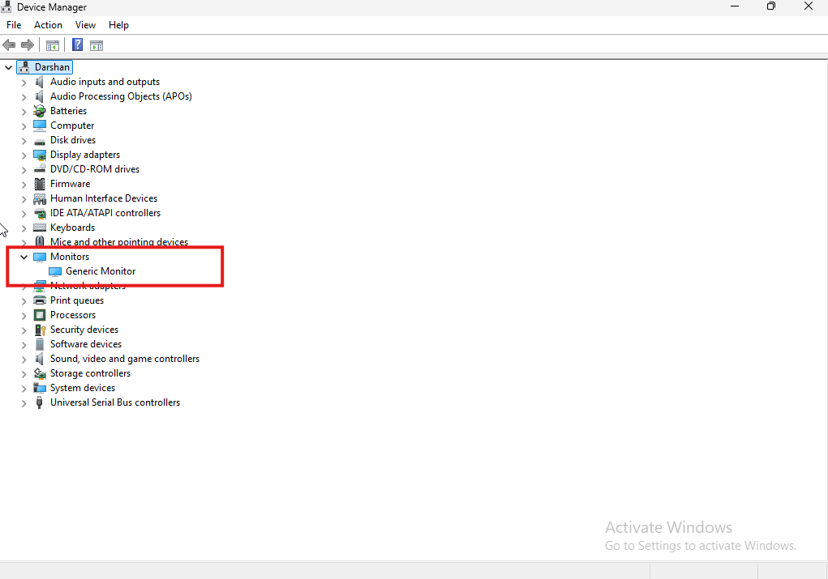

Action Performed:
- Opened Device Manager.
- Expanded the Monitors category.
- Checked whether Windows detected the connected monitor.
Result:
- Monitor detection was reviewed through Device Manager.
- The monitor entry was visible in Device Manager.

- Review display resolution and scaling settings.
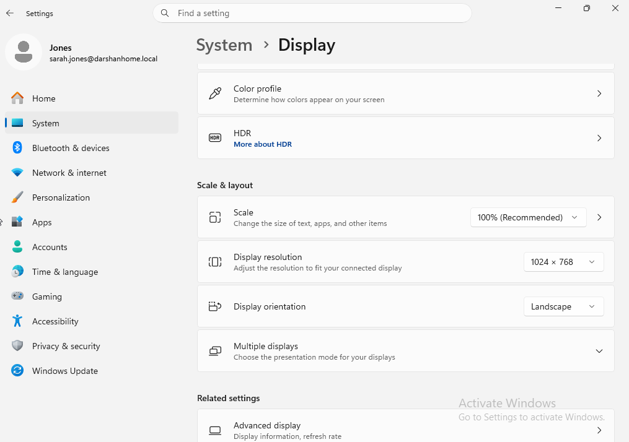

Action Performed:
- Opened Settings → System → Display.
- Reviewed the current display resolution.
- Checked the scaling percentage.
- Reviewed the available display configuration settings.
Result:
- Display resolution and scaling settings were successfully accessed and reviewed.
- Current display configuration was documented for troubleshooting reference.

- Check refresh rate and display configuration.
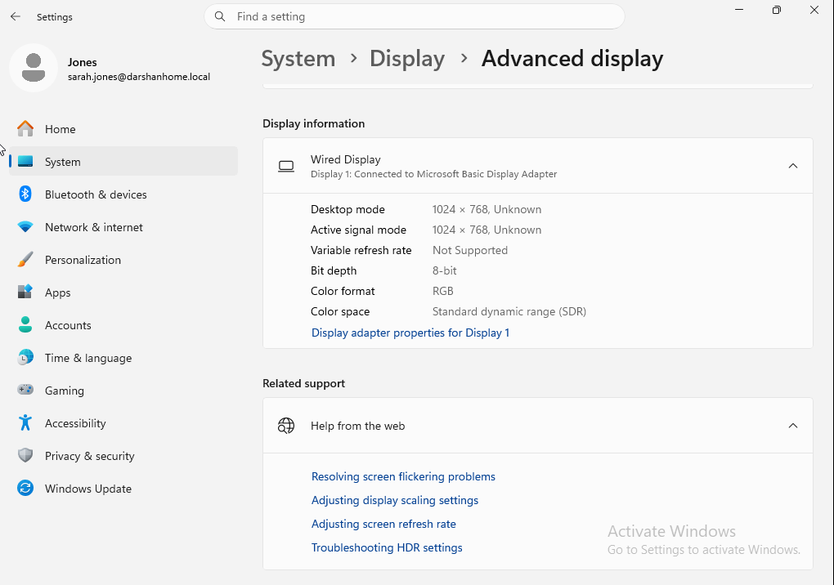

Action Performed:
- Opened Settings → System → Display → Advanced display.
- Reviewed the available display configuration information.
- Checked whether Windows exposed refresh-rate settings.
Result:
- Advanced display settings were successfully accessed.
- A refresh-rate selection was not available in the VMware virtual machine.
- This is a limitation of the virtual display environment and does not confirm a physical monitor fault.

- Inspect the graphics adapter and driver status in Device Manager.
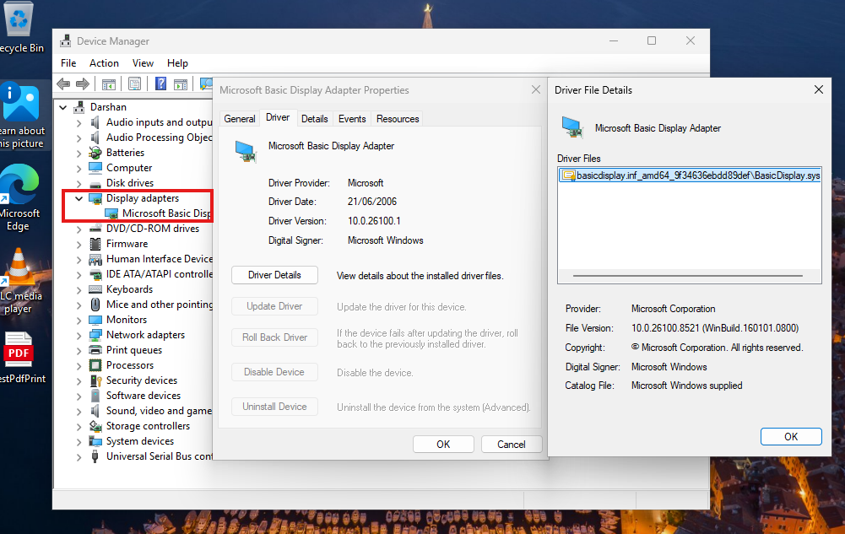
Action Performed:
- Opened Device Manager and expanded Display adapters.
- Identified the graphics adapter used by the VMware virtual machine.
- Reviewed the adapter's device status and driver information.
Result:
- Windows detected the virtual graphics adapter.
- Device status reported that the device was working properly.
- No graphics adapter warning was identified.

- Check for relevant display-related errors if necessary.
Action Performed:
- Reviewed Device Manager for display adapter warnings or error indicators.
- Checked Windows Display Settings for configuration issues.
- Inspected the graphics adapter and driver status.
- No additional display-related errors were identified during the checks.
Result:
- No display adapter errors or driver warnings were observed.
- Windows display configuration appeared normal.
- No corrective action was required.
Ticket outcome: Closed – No Fault Found.

Scenario 9 – User Account Control (UAC) and Local File Access
Ticket ID: INC-009
User: Sarah Jones
Department: IT
Workstation: Windows 11 Desktop
Category: User Access / Permissions
Priority: P3 – Medium
Status: Open – In Progress
Assigned To: Level 1 IT Support
User Reported Issue
Sarah Wilson contacted the IT Help Desk reporting that she was unable to modify certain files and folders on her Windows 11 workstation. She also encountered User Account Control (UAC) prompts when attempting to run an application requiring administrator privileges.
The user was unsure whether the issue was related to her Windows account permissions or a security restriction.
Business Impact
The user can sign in to Windows and perform normal tasks. However, restricted file access and administrator approval requirements may prevent her from completing certain activities.
Initial Troubleshooting Plan
- Verify the logged-in user account and workstation.
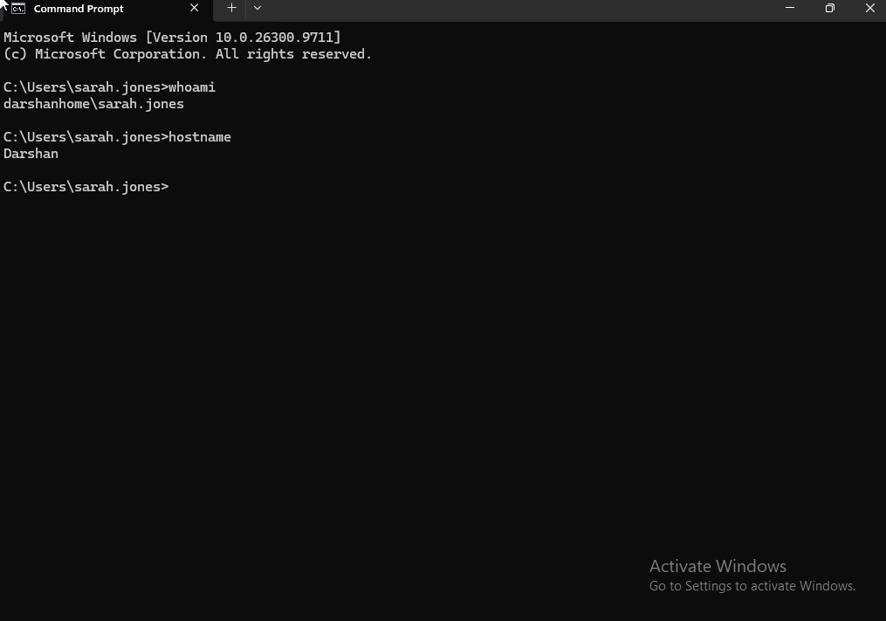

- Check whether the account is configured as a Standard User or Administrator.
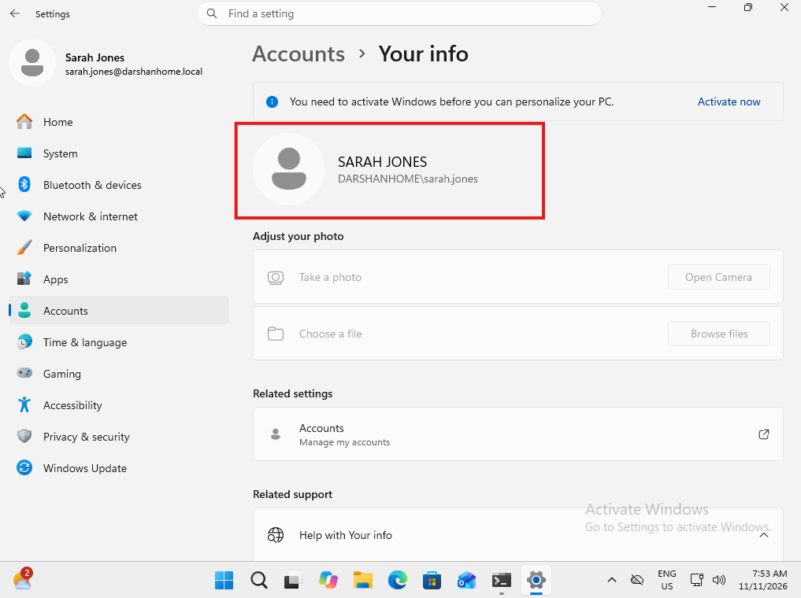

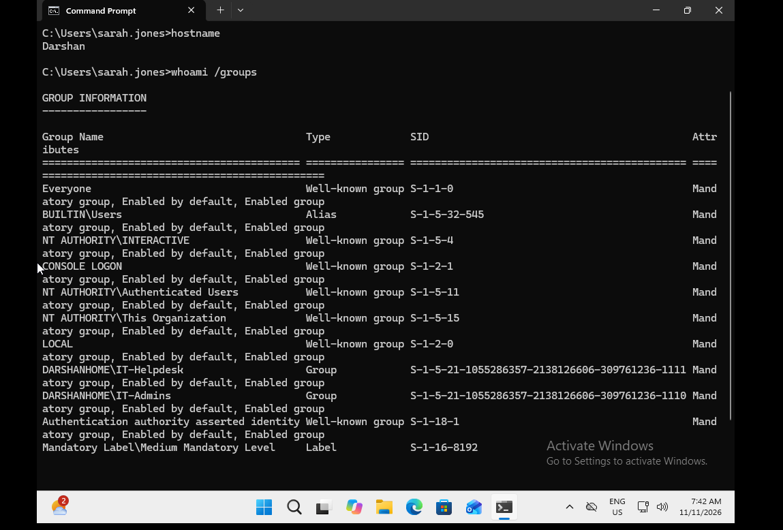

Action Performed:
- Opened Windows Settings → Accounts → Your info to identify the logged-in domain account.
- Executed whoami /groups in Command Prompt.
- Reviewed the security groups associated with the logged-in account.
Result:
- Confirmed that the account belongs to the darshanhome.local domain.
- Identified membership in the Everyone and BUILTIN\Users groups.
- No membership in the local BUILTIN\Administrators group was displayed.
- The account was identified as a Standard User for this test.

- Review UAC behaviour when launching an application requiring elevated privileges.
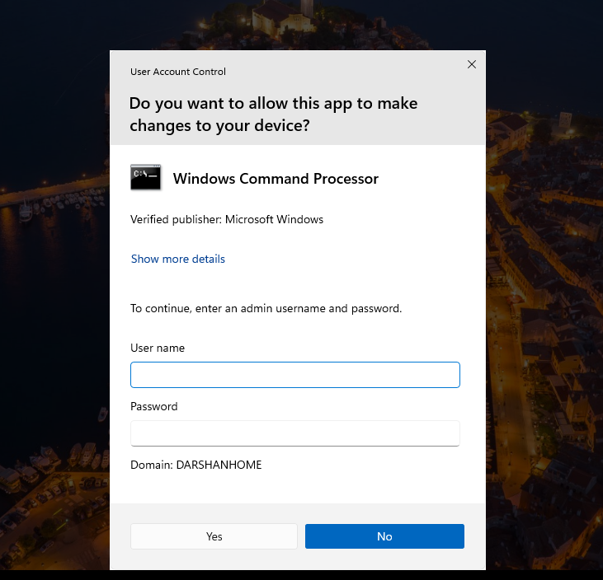

Action Performed:
- Right-clicked Command Prompt and selected Run as administrator.
- Observed the User Account Control security prompt.
- Reviewed the administrator credential requirement.
Result:
- Windows displayed a UAC credential prompt when attempting to launch Command Prompt with elevated privileges.
- The standard user account could not independently approve the administrative operation.
- Administrator credentials were required to proceed.

- Inspect local folder permissions through the Security tab.
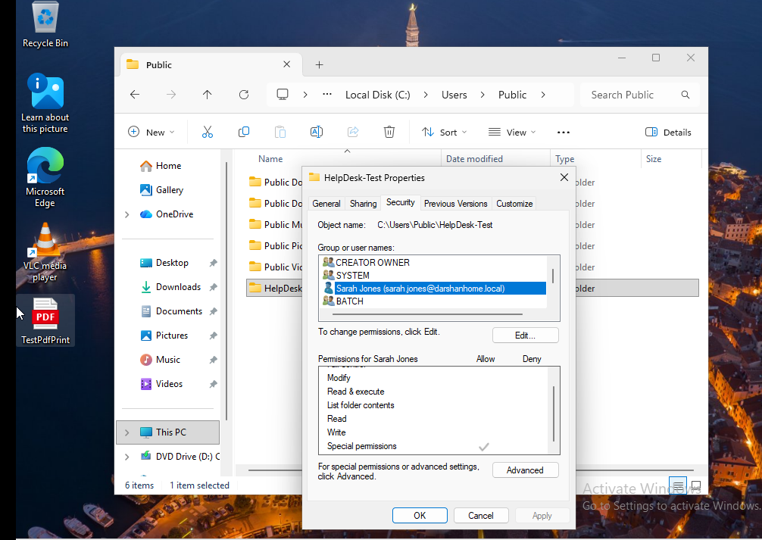

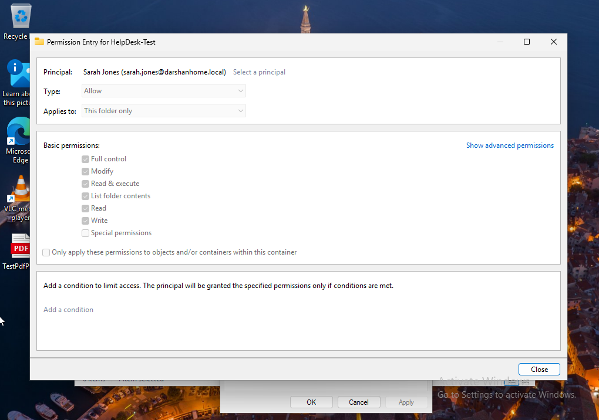
Action Performed:
- Created a test folder named HelpDesk-Test under C:\Users\Public\Documents.
- Opened the folder's Properties and selected the Security tab.
- Reviewed the permissions assigned to Sarah Wilson's account.
- Opened Advanced Security Settings to inspect the detailed permission entry and inheritance scope.
Result:
- Identified that Sarah Wilson's account had special NTFS permissions assigned.
- Advanced Security Settings showed Allow – Full control – This folder only.
- Confirmed that the permission entry applied to the test folder itself.
- No permission changes were made during the inspection.

- Test basic file access operations using an authorised test folder.
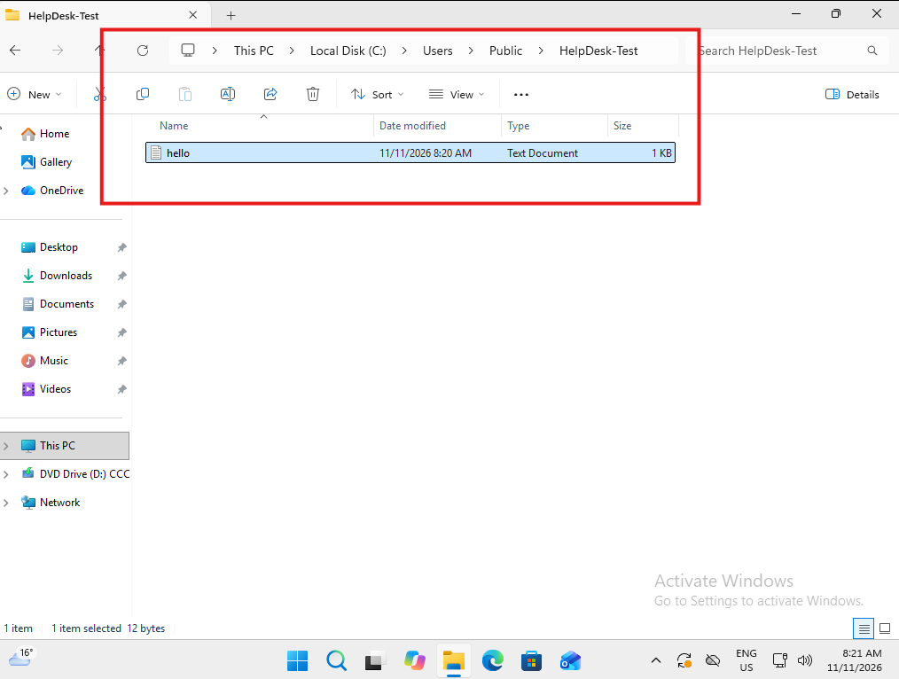

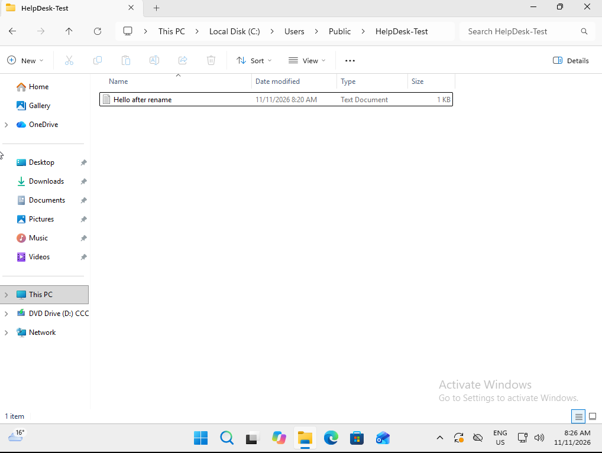
Action Performed:
- Opened the HelpDesk-Test folder.
- Created a text file named Test.txt.
- Entered sample text into the file.
- Saved the file successfully.
- Opened the HelpDesk-Test folder.
- Created a text file named Test.txt.
- Entered sample text and saved the file.
- Renamed the text file successfully.

Result:
- Successfully created and modified the test text file.
- Confirmed that Sarah Wilson could write data to the HelpDesk-Test folder.
- No access-denied errors were encountered during the test.
- Opened the HelpDesk-Test folder.
- Created a text file named Test.txt.
- Entered sample text and saved the file.
- Renamed the text file successfully.

- Record findings and determine whether the issue requires permission changes or escalation.
Action Performed:
- Reviewed Sarah Wilson's domain account group membership.
- Tested UAC behaviour when attempting to launch an application with elevated privileges.
- Inspected local NTFS folder permissions.
- Tested creating, editing and renaming a text file in the authorised test folder.
- Reviewed the results to determine whether additional permissions were required.
Result:
- Confirmed that Sarah's account operates as a Standard User.
- UAC requires administrator credentials for administrative operations.
- Sarah successfully created, edited and renamed files in the authorised test folder.
- No file access restrictions were identified within the test folder.
- No additional file permissions were required for the tested operations.
- Administrative tasks would require assistance from an authorised administrator.

Final Ticket Status: Closed – No Fault Found (Expected Security Behaviour).

Scenario 10 – Disk space and storage
Incident INC-010 – Low Disk Space and Storage Issues
Ticket ID: INC-010
User: Sarah Jones
Department: IT
Workstation: Windows 11 Desktop
Category: Hardware / Storage
Priority: P3 – Medium
Status: Open – In Progress
Assigned To: Level 1 IT Support
User Reported Issue
Sarah Jones reports receiving low disk space notifications on his Windows 11 workstation. He is also experiencing difficulties saving files and installing software.
Business Impact
Limited available storage may affect the user's ability to save documents, install applications and perform normal work activities.
Initial Troubleshooting Plan
- Verify the logged-in user and workstation.
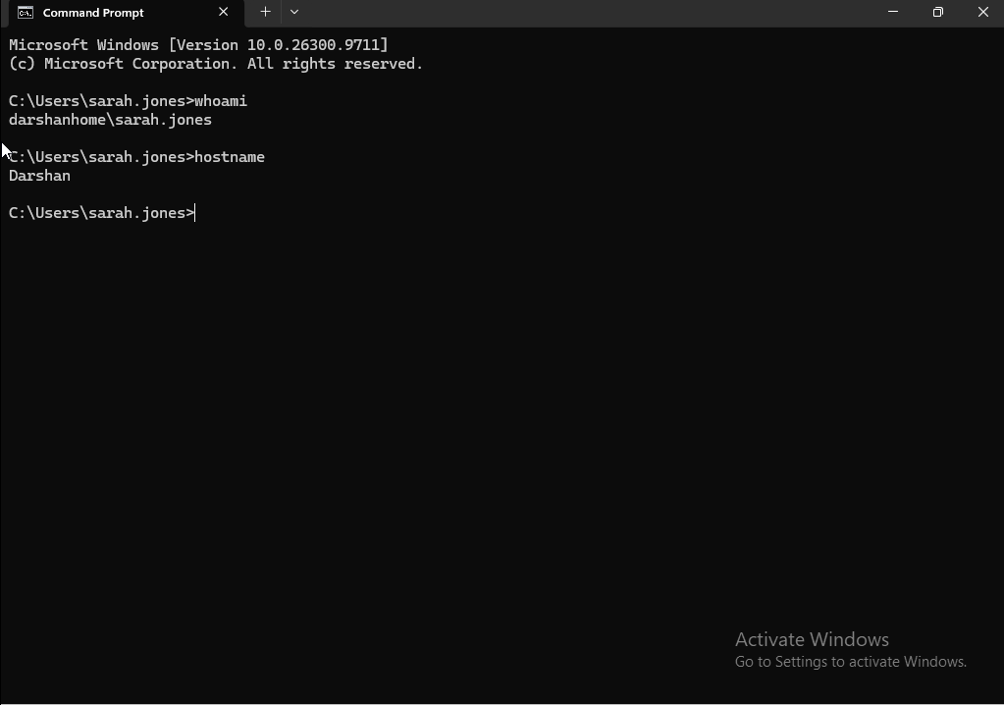

- Check available disk space using Windows Settings.
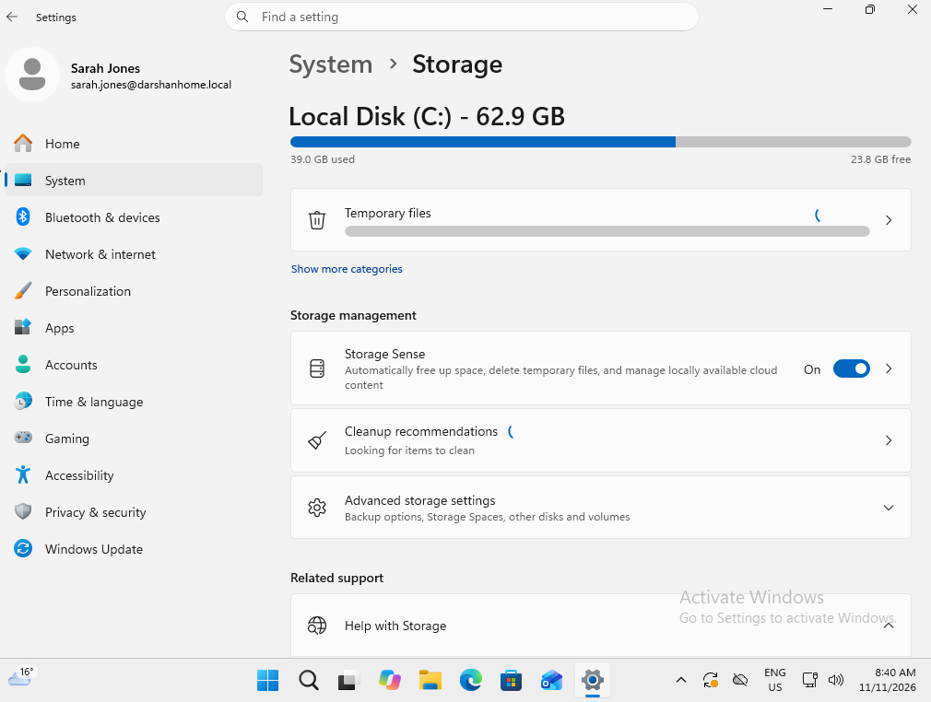

Action Performed:
- Opened Windows Settings → System → Storage.
- Reviewed the total storage capacity, used storage and available free space.
Result:
- Total storage capacity: 62.9 GB.
- Used storage: 39.0 GB.
- Available free space: 23.8 GB.
- Approximately 38% of the storage capacity was available.
- No critically low storage condition was identified during this inspection.

- Inspect storage usage and identify which categories consume the most space.
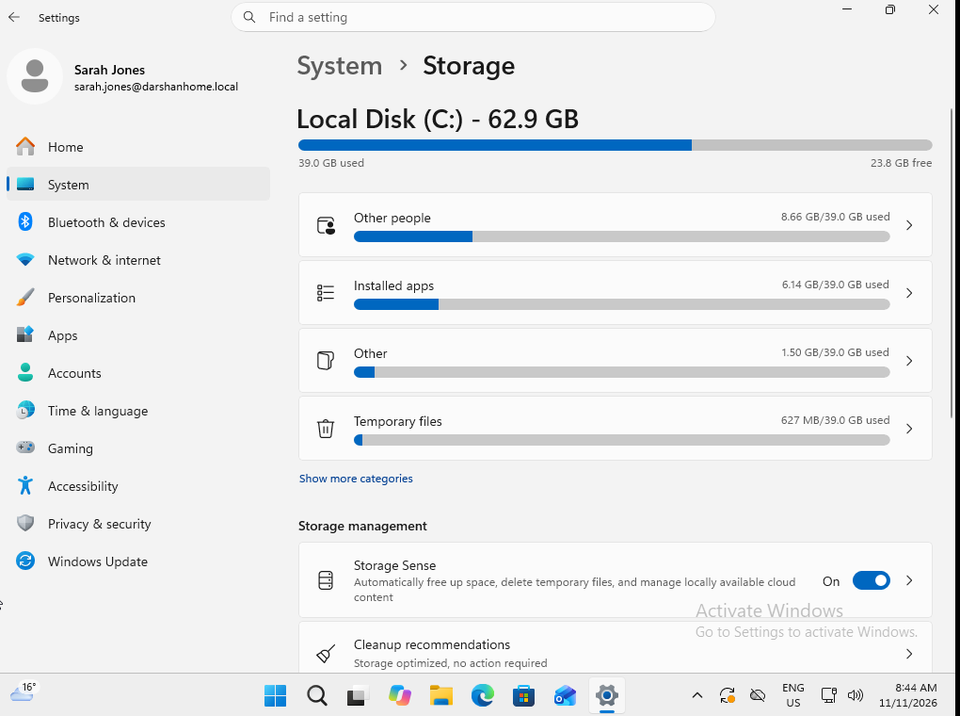
Action Performed:
- Opened Settings → System → Storage.
- Reviewed the storage categories and their reported usage.
- Identified Other people as the category consuming the most storage space.
Result:
- Other people was identified as the largest reported storage category.
- The category was flagged for further investigation to determine which user profiles were consuming the storage.
- No files or user profiles were deleted.

- Check temporary files and Windows storage cleanup options.
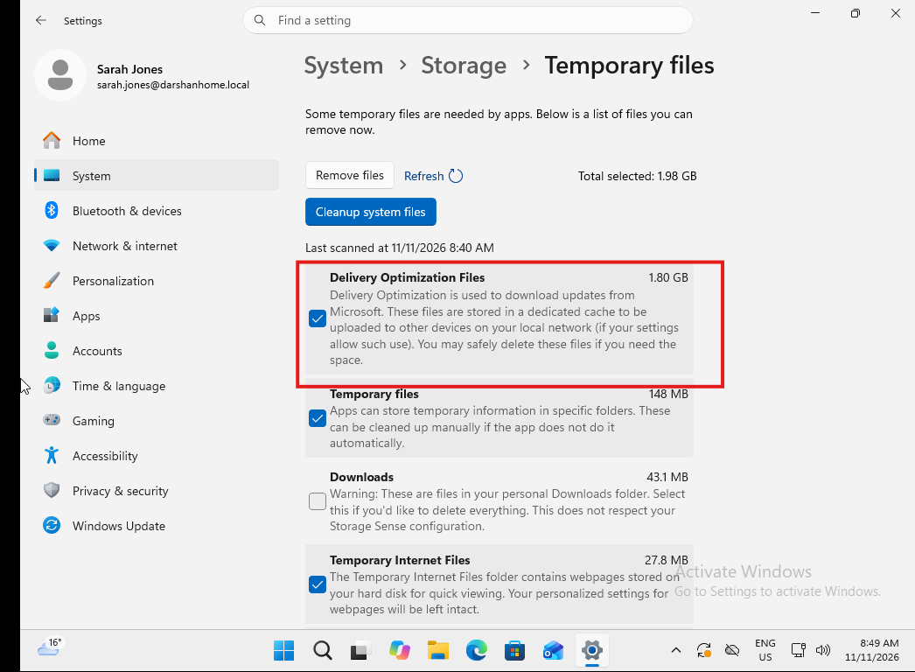

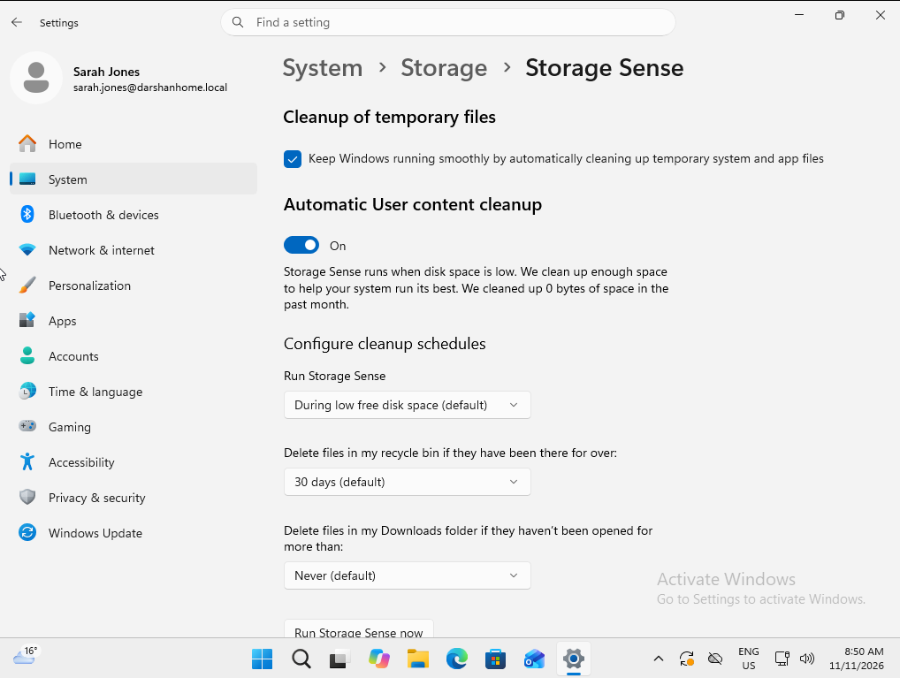
Action Performed:
- Opened Settings → System → Storage → Temporary files and reviewed the temporary file categories.
- Identified Delivery Optimisation Files as the largest temporary-file category, consuming approximately 2 GB. Other categories were using relatively little storage.
- Reviewed the Cleanup recommendations section and checked the Storage Sense configuration.
- Confirmed that Storage Sense was enabled and configured to run when disk space was low.
- Reviewed the recommendation to delete files from the Downloads folder but did not select it, as Downloads may contain personal or important user files.
Result:
- Identified Delivery Optimisation Files as a potential storage-cleanup opportunity.
- Confirmed that Storage Sense was enabled to help manage temporary files when disk space becomes low.
- No files were deleted and no settings were changed.
- Downloads were excluded from cleanup to avoid removing potentially important user data.

- Inspect disk health and identify any obvious storage-related warnings.
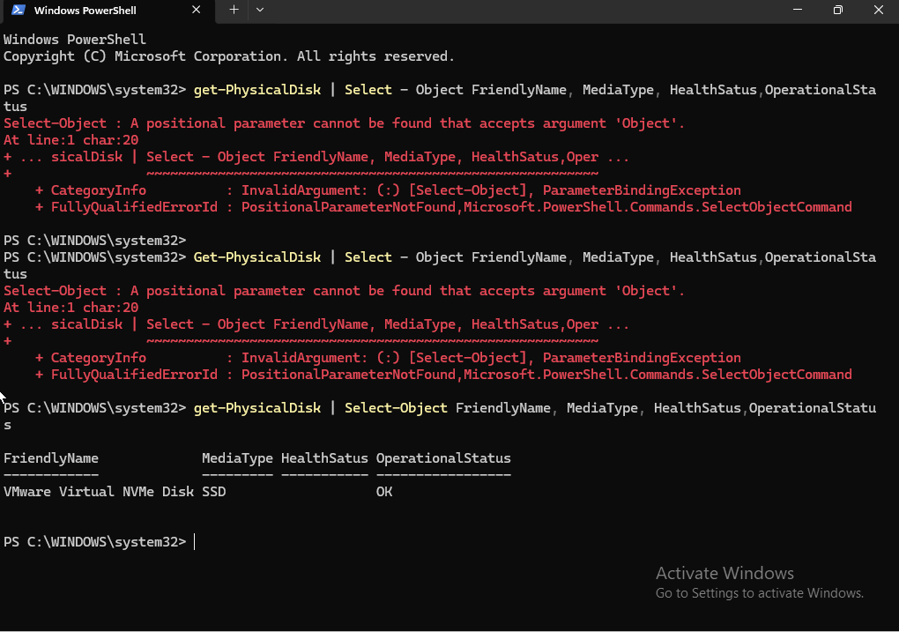

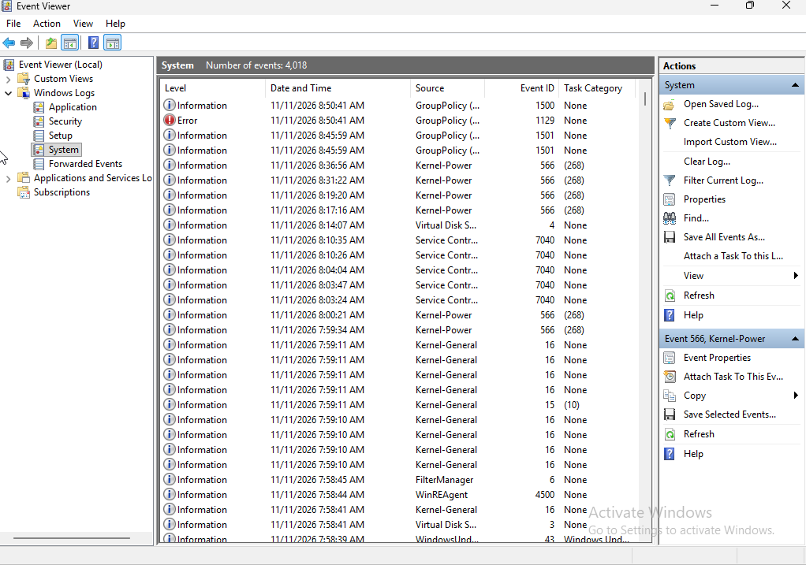

Action Performed:
- Opened PowerShell and ran the Get-PhysicalDisk command to inspect the virtual disk's reported health status.
- Reviewed the disk health and operational status.
- Opened Event Viewer and navigated to Windows Logs → System.
- Reviewed recent warnings and errors for storage-related events, including Disk and NTFS.
Result:
- PowerShell reported the VMware virtual disk health status as Healthy.
- No relevant disk or file-system errors were identified in the reviewed System event logs.
- No obvious storage-related warnings were found during the checks.
- No repairs or configuration changes were required.

- Perform authorised cleanup if required.
Action Performed:
- Reviewed the available storage capacity and temporary-file categories.
- Considered the Windows Cleanup Recommendations and Storage Sense settings.
- Evaluated whether manual cleanup was necessary.
- No files were deleted because sufficient free storage was available and no critical storage issue was identified.
Result:
- No cleanup was required at the time of investigation.
- Existing user files, including Downloads, were preserved.
- No system settings or storage configurations were changed.
- No risk of unnecessary data loss was introduced.

Technician Assessment:Manual cleanup was not performed because the available evidence did not indicate an urgent storage issue. Further cleanup can be considered if storage usage increases or the user continues experiencing low-storage notifications.

Scenario 11 – Windows system file and component repair
Scenario 11 – Windows System File and Component Repair
IT Support Ticket
Ticket ID: INC-011
User: Sarah Jones
Department: IT
Device: Windows 11 Desktop
Category: Windows Operating System / System Integrity
Priority: P3 – Medium
Status: Open – In Progress
Assigned To: Level 1 IT Support
User Report
The user reports that their Windows 11 computer has recently been behaving unexpectedly. Some Windows features are not responding as expected, and the user has experienced occasional application errors.
The user suspects that Windows system files may be corrupted and requests assistance.
Initial Assessment
The issue may be related to Windows system-file corruption or problems within the Windows component store. Further investigation is required to identify the cause.
Troubleshooting Plan
- Verify the user's identity, device name and Windows version.
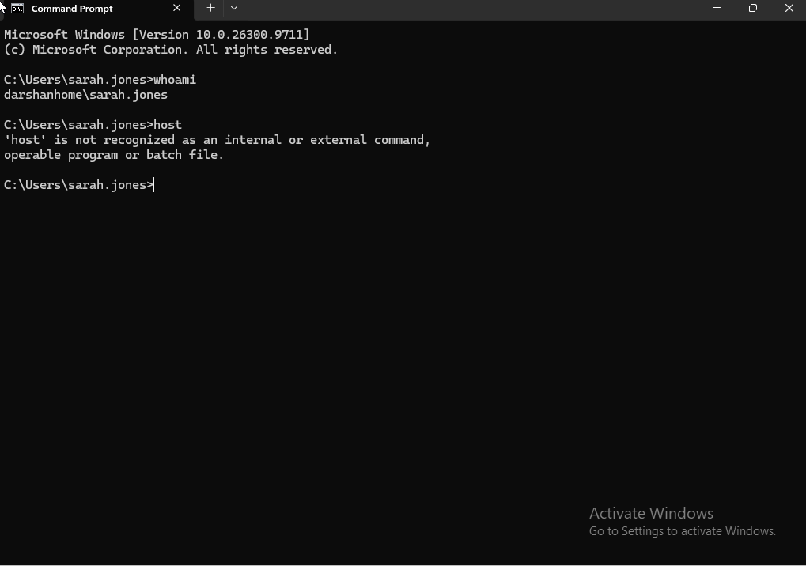

- Run System File Checker (SFC) to check the integrity of protected Windows system files.
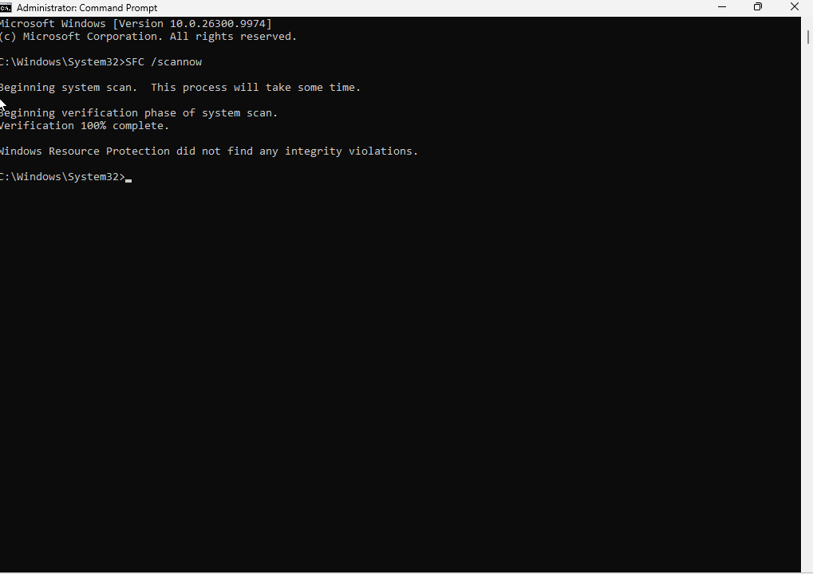
Action Performed:
- Opened Command Prompt with administrator privileges.
- Executed sfc /scannow.
- Allowed the system-file verification process to complete.
- Reviewed the final scan result.
Result:
- SFC completed successfully.
- Windows Resource Protection did not find any integrity violations.
- No corrupted or missing protected system files were detected.
- No system-file repairs were required.

- Use DISM to inspect the Windows component store for corruption.
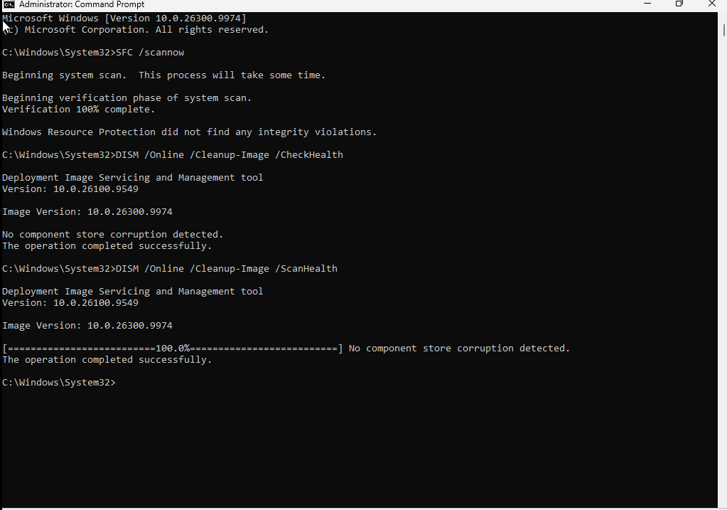

Action Performed:
- Opened Command Prompt with administrator privileges.
- Executed DISM /Online /Cleanup-Image /CheckHealth.
- Executed DISM /Online /Cleanup-Image /ScanHealth.
- Allowed both operations to complete and reviewed the results.
Result:
- DISM reported that no component store corruption was detected.
- No repairable component-store issues were identified.
- No Windows component-store repairs were required.

- Perform component-store repair if corruption is identified and repair is appropriate.
Action Performed:
- Reviewed the results of the DISM /CheckHealth and /ScanHealth commands.
- Confirmed that Windows did not detect component-store corruption.
- Determined that component-store repair was not required.
- Did not execute DISM /Online /Cleanup-Image /RestoreHealth, as no corruption was identified.
Result:
- No component-store corruption was detected.
- No repair operation was necessary.
- No Windows servicing or system configuration changes were made.

Conditional Repair Procedure – If Windows Corruption Is Detected
If SFC identifies corrupted system files, I would first review the scan results and use DISM to inspect the Windows component store. If DISM identifies repairable corruption, I would execute DISM /Online /Cleanup-Image /RestoreHealth to attempt to repair the component store. Once the repair is completed successfully, I would run sfc /scannow again to verify and repair protected Windows system files. I would then restart the computer if required, verify that the original issue has been resolved, document the results and escalate the issue if corruption remains or the repair fails.

Scenario 12 – File Explorer, search and profile symptoms
Scenario 12 – File Explorer, Windows Search and User Profile Troubleshooting
IT Support Ticket
Ticket ID: INC-012
User: Sarah Jones
Department: IT
Device: Windows 11 Desktop
Category: Windows Operating System / User Profile
Priority: P3 – Medium
Status: Open – In Progress
Assigned To: Level 1 IT Support
User Report
The user reports that File Explorer has become slow and occasionally stops responding when opening folders or accessing files.
The user also reports that Windows Search is not consistently returning expected results when searching for documents and applications.
Additionally, the user has noticed that some desktop shortcuts and personal settings appear to be missing after signing in.
The user requests assistance investigating these issues.
Initial Assessment
The reported symptoms may be related to Windows Explorer performance, Windows Search indexing or a user-profile loading issue.
Further investigation is required to identify whether the problems are related or caused by separate issues.
Troubleshooting Plan
- Verify the user's identity, workstation name and Windows version.

- Investigate File Explorer responsiveness and check whether Windows Explorer is operating normally.
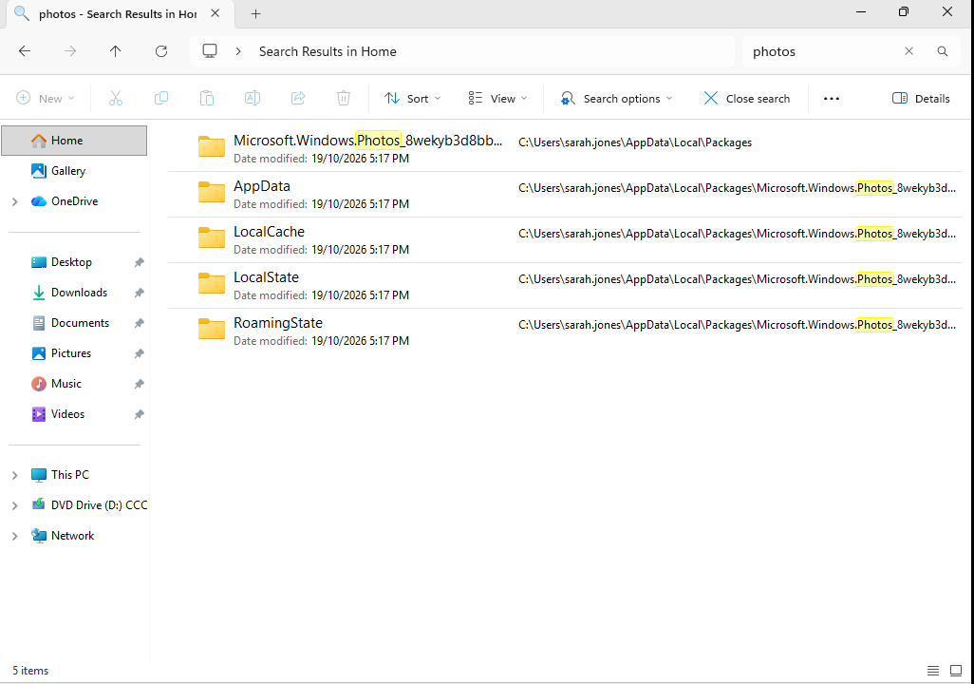

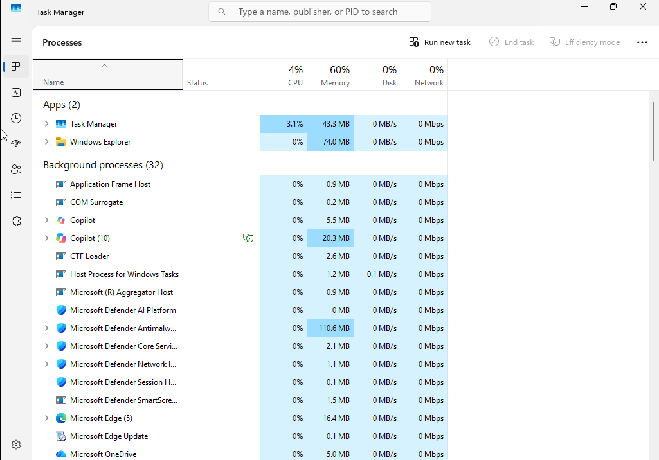

Action Performed:
- Opened File Explorer using Windows + E.
- Navigated through Home, This PC, Documents and Downloads.
- Checked whether folders opened and loaded correctly.
- Opened Task Manager and located the Windows Explorer process.
- Reviewed CPU usage to identify any unusual resource consumption.
Result:
- File Explorer opened and operated normally during testing.
- Folders were accessible and responsive.
- Windows Explorer was running in Task Manager.
- CPU usage was reported as 0% at the time of inspection.
- No obvious File Explorer performance or responsiveness issues were identified.

- Check Windows Search functionality and review indexing status.
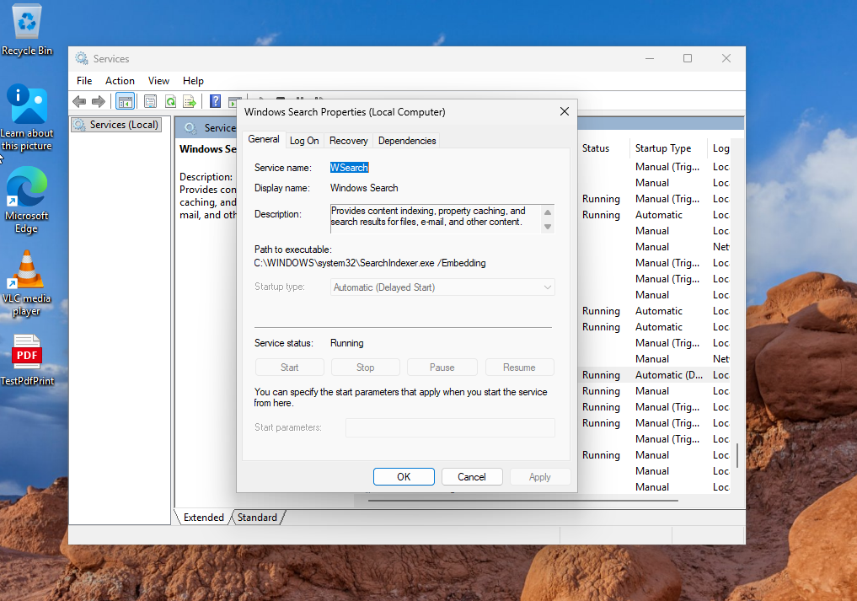

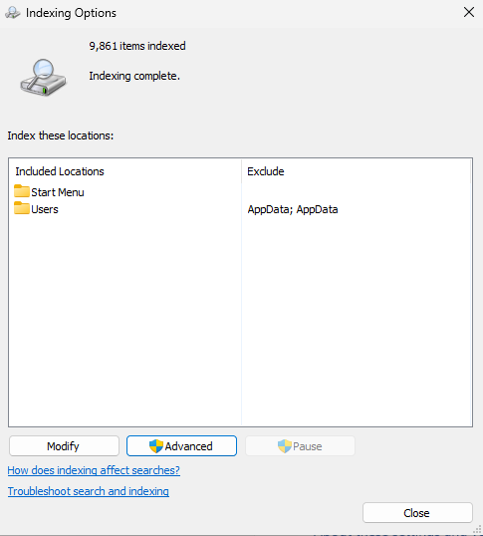

Action Performed:
- Opened the Windows Services management console (services.msc).
- Located the Windows Search service and checked its operational status.
- Opened Windows Settings → Privacy & security → Searching Windows.
- Reviewed the configured indexing locations.
- Confirmed that the Start menu was included as an indexed location.
Result:
- Windows Search service was running during the inspection.
- The Start menu was included in the configured indexing locations.
- No service-related issue was identified during the check.
- Further search testing would be required to confirm that applications and files are returned correctly.

- Investigate the user-profile loading behaviour and check for temporary-profile notifications or errors.
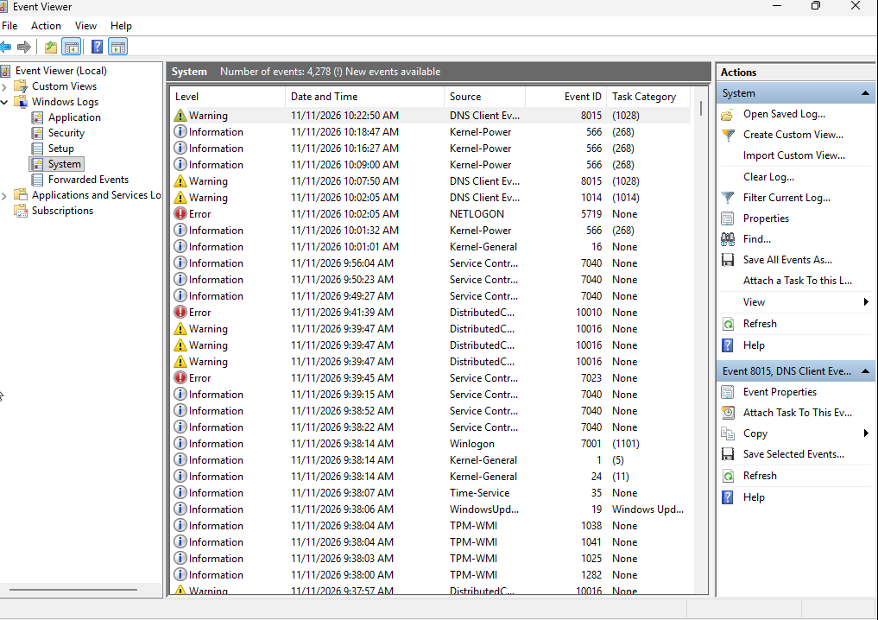

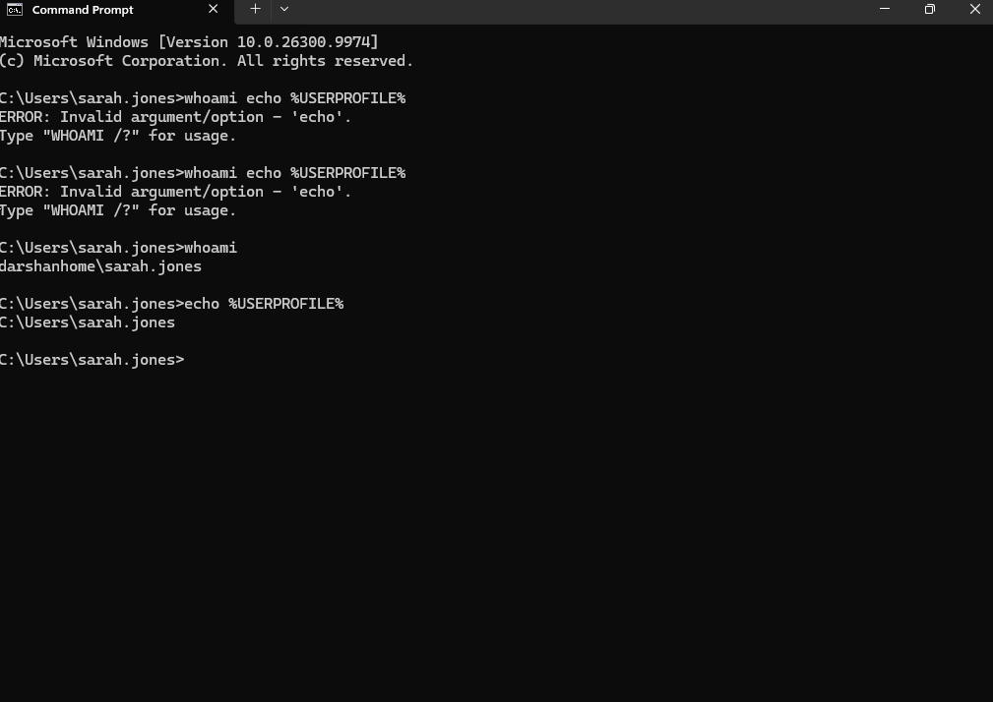

Action Performed:
- Signed in using the existing Windows user account.
- Observed the Windows sign-in process and checked for temporary-profile notifications.
- Verified that the normal desktop environment and user settings loaded correctly.
- Checked the current user profile using Command Prompt:
whoami
echo %USERPROFILE%
- Opened Event Viewer → Windows Logs → Application.
- Reviewed recent events for User Profile Service warnings or errors.
Result:
- Windows loaded the existing user profile successfully.
- No temporary-profile notification was displayed.
- The normal desktop environment and user settings were available.
- No relevant User Profile Service warnings or errors were identified in the reviewed logs.
- No profile corruption was identified during the investigation.

- Perform appropriate troubleshooting actions based on the findings.
Action Performed:
- Reviewed the findings from the File Explorer, Windows Search and user-profile investigations.
- Confirmed that Windows Explorer was operating normally.
- Confirmed that the Windows Search service was running and the Start menu was included in the indexed locations.
- Confirmed that the existing user profile loaded normally.
- Determined that no corrective actions or system configuration changes were required.
Result:
- No obvious File Explorer performance issues were identified.
- No Windows Search service issue was identified during the checks.
- No temporary-profile or user-profile loading issues were detected.
- No system repairs, service restarts or profile modifications were necessary.
Technician Assessment:
No faults were identified during the investigation. Further troubleshooting was not required, and the system was left unchanged.

Conditional Troubleshooting Procedure – If User Profile Errors Are Identified
If Event Viewer displays User Profile Service warnings or errors, I would review the event details, identify the affected user account and investigate the cause of the profile-loading issue. If Windows signs in using a temporary profile, I would verify the user's normal profile path, check the profile service and investigate relevant profile-related errors. I would avoid deleting or modifying the user profile or Windows Registry without appropriate authorisation and a verified backup. If the issue cannot be resolved through standard Level 1 troubleshooting, I would document the findings and escalate the incident to the appropriate support team.

Scenario 13 – Security alerts and suspected malware
Scenario 13 – Security Alerts and Suspected Malware
IT Support Ticket
Ticket ID: INC-013
User: Sarah Jones
Department: IT
Device: Windows 11 Desktop
Category: Information Security / Suspected Malware
Priority: P2 – High
Status: Open – Security Escalation Required
Assigned To: Level 1 IT Support
User Report
The user reports receiving a Windows Security notification indicating that a potentially unwanted or suspicious application has been detected on their computer.
The user is unsure whether the notification is legitimate and has requested assistance.
The user also reports noticing an unfamiliar application on the computer recently. They are concerned that their device may have been exposed to malware.
Initial Assessment
The notification and unfamiliar application require investigation to determine whether the alert is legitimate and whether the device may be compromised.
The issue will be handled according to the organisation's security incident-response procedures.
Troubleshooting and Investigation Plan
- Verify the user's identity, workstation name and Windows version.

- Review the Windows Security notification and identify the reported threat.
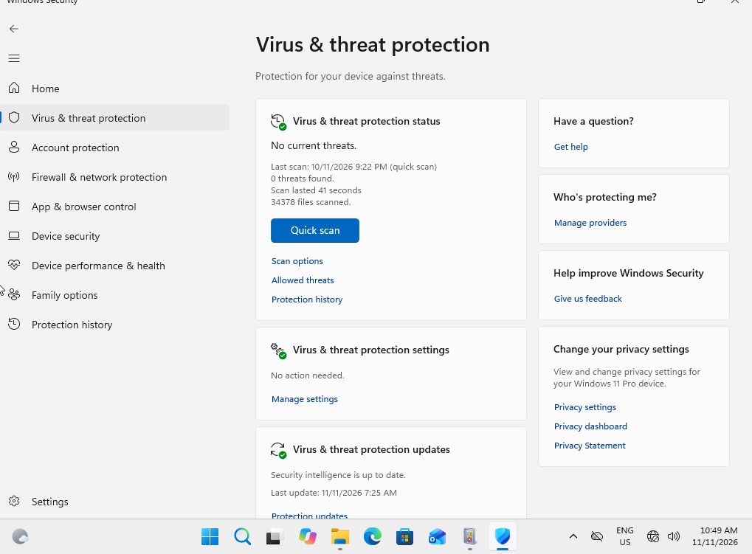

Action Performed:
- Opened Windows Security.
- Navigated to Virus & threat protection.
- Reviewed the current security status and checked for reported threats.
- Inspected the displayed threat-protection information.
Result:
- Windows Security displayed No current threats.
- No active threat was reported on the Virus & threat protection screen at the time of inspection.
- No specific malware detection was identified during this check.
- Further investigation of Protection History was required to determine whether any previous detections or alerts had been recorded.

- Open Windows Security and review Protection History for relevant detection details.
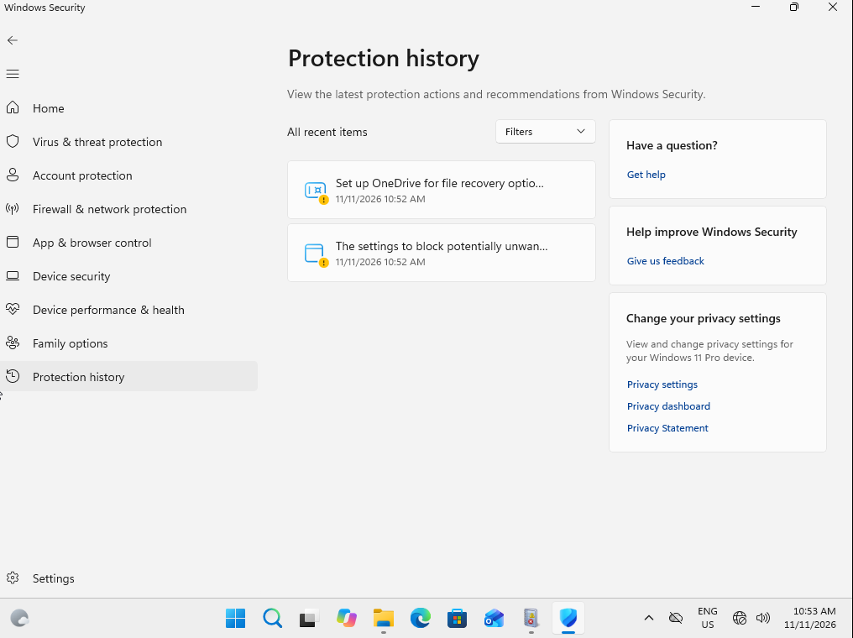
Action Performed:
- Opened Windows Security.
- Navigated to Virus & threat protection → Protection history.
- Reviewed the available history for detected threats, quarantined items and recommended security actions.
Result:
- No threat detections were displayed in Protection History.
- No quarantined items or pending security actions were identified.
- No previous malware detection was recorded in the history reviewed.
- No suspicious activity was identified through this check.

- Perform an authorised antivirus scan and review the results.
Action Performed:
- Opened Windows Security.
- Navigated to Virus & threat protection.
- Initiated a Microsoft Defender Quick Scan.
- Allowed the scan to complete.
- Reviewed the final scan results.
Result:
- Microsoft Defender Quick Scan completed successfully.
- No threats were detected during the scan.
- No quarantine or remediation action was required.
- No security configuration changes were made.

Technician Assessment:
No malware was detected during the Quick Scan. This is a positive result, although a Quick Scan does not guarantee that every file or location on the device is free from threats.

- Verify the device's security status following authorised remediation.
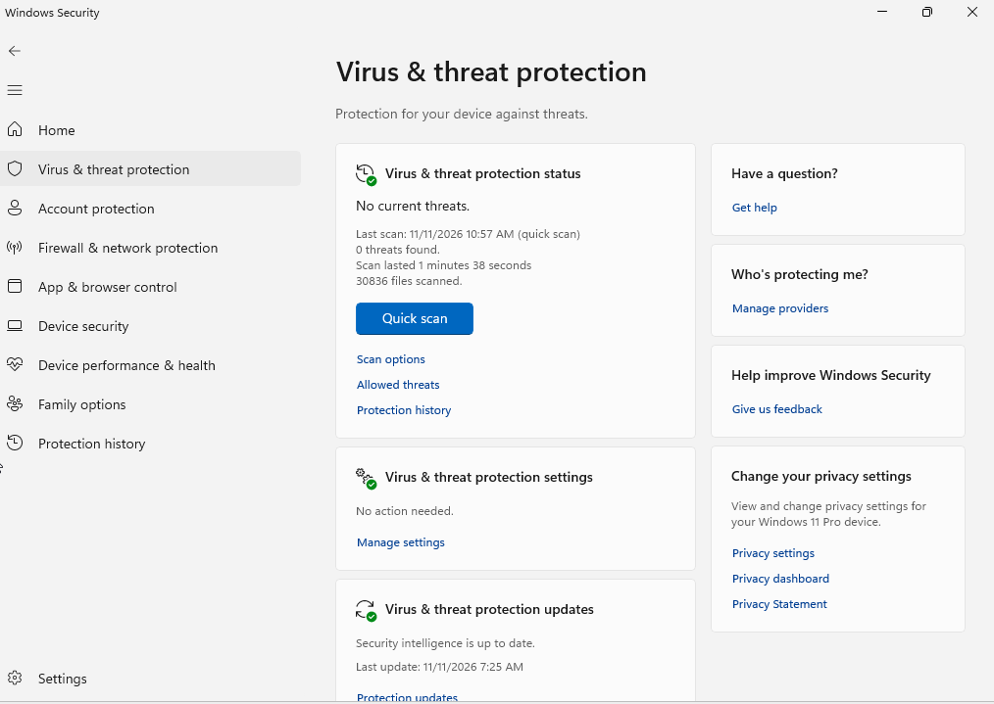

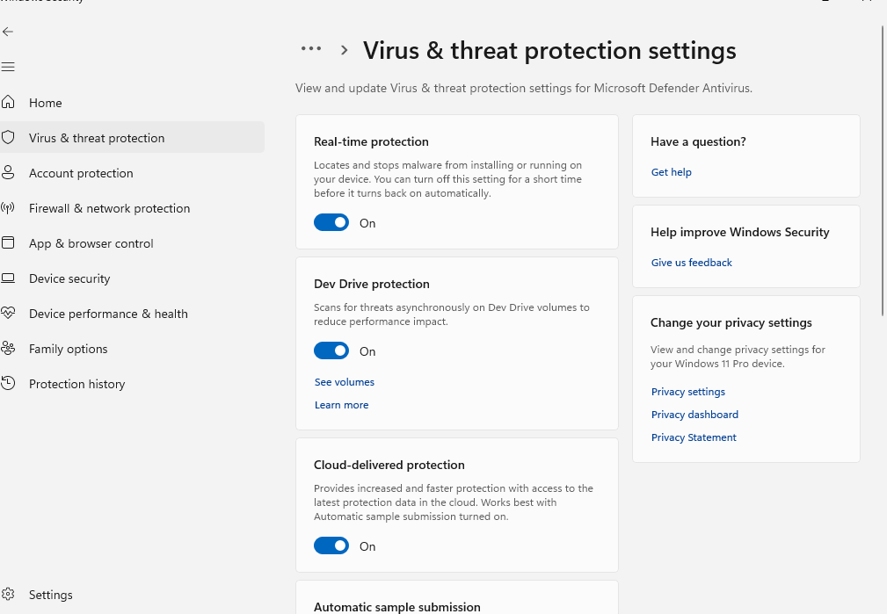

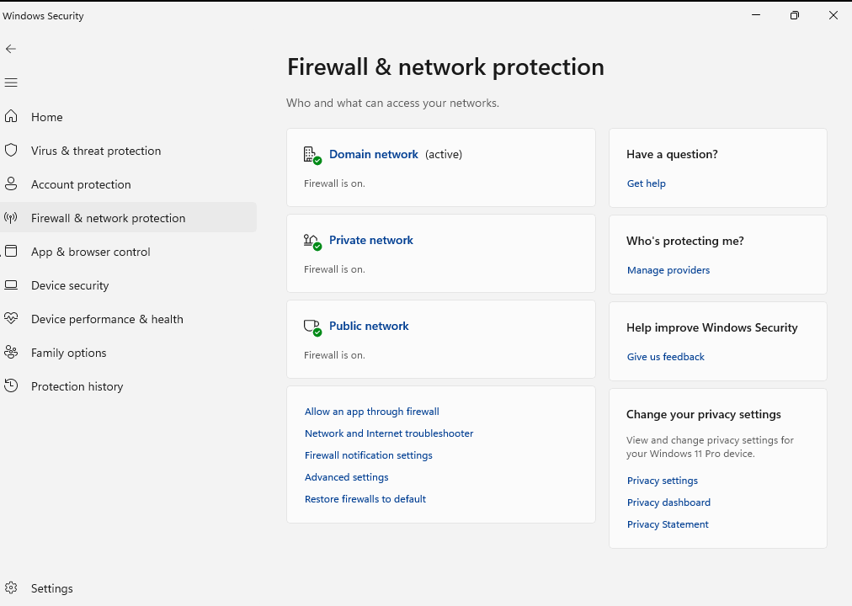

Action Performed:
Reviewed Windows Security to verify the device's security status following the investigation. Confirmed Microsoft Defender Quick Scan results, Protection History, antivirus protection settings and Windows Firewall status.
Result:
- Microsoft Defender Quick Scan completed with no threats detected.
- Protection History showed no threat detections or pending actions.
- Real-time protection, Cloud-delivered protection, Automatic sample submission and Tamper Protection were enabled.
- Windows Firewall was enabled.
- No malware remediation was required based on the available findings.
  - No security settings were modified.

If any security threat is detected, I will follow the organisation's incident response procedures, promptly report and escalate it through the appropriate channels, and notify relevant personnel of any potential risks. I will not access suspicious links, download or install unfamiliar software, or make changes to the affected device without proper authorisation.

